11.11513.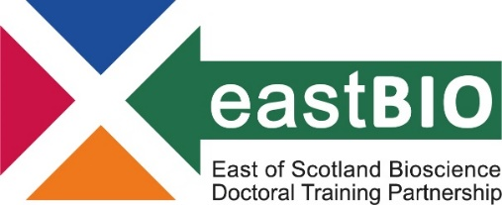

EASTBIO DTP Foundation Masterclasses 2022/23 – Set 3
Introduction to Proteomics and Mass Spectrometry
Course leader: Mr Kevin McLean (Moredun Research Institute)
Date: 30 May 2022, 11:30-17:00
Venue: Moredun Research Institute, Pentlands Science Park, EH26 0PZ
Summary:
Proteomics is the large scale study of proteins. A proteome is defined as the entire set of proteins expressed by a cell or an organism at a given time under defined conditions. Proteomes are dynamic and can change quickly due to environmental conditions and stimulus. Proteomic analysis provides identification and molecular characterisation of the proteins found in a sample, this data, together with downstream bioinformatic analyses, can provide detailed information on protein structure and function, regulation of protein expression, post-translational modifications and the molecular interactions of proteins during both normal physiological and diseased states.
Proteomic analysis is underpinned by the use of mass spectrometry which enables the identification, characterisation and quantitation of proteins. The complex data sets produced by mass spectrometers are analysed using a range of data analysis platforms that enable researchers to assign functions to identified proteins, study protein interactions and interpret expression patterns.
This course will cover the basic principles of proteomics and mass spectrometry. Commonly used proteomic workflows will be discussed and a range of mass spectrometry instrumentation explored. Applied examples will be used to give context and demonstrate outputs. Participants will be introduced to a range of software tools routinely used to analyse and interpret mass spec data in the Proteomics facility, including the open source MaxQuant and Perseus applications. There will also be a tour of the Moredun Proteomics facility to allow participants to see the instrumentation in operation.
Learning outcomes:
Overall, this course will provide participants a solid foundation in the principles of proteomics and equip them with the knowledge to apply this technology to their own biological questions.
Schedule:
10:30-11:30 | Seminar - Introduction to Proteomics
11:45-12:00 | Coffee/tea break
12:00-13:15 | Seminar - Introduction to Mass Spectrometry
13:15-14:00 | Lunch
14:00-14:30 | Tour of Proteomics Facility
14:30-15:30 | Seminar - Introduction to Quantitative Proteomics
15.30-15:50 | Coffee/tea break
15:50-17:00 | Proteomic Data Analysis software packages

Requirements:
EASTBIO may provide some of the masterclass materials after prior communication with the leaders and upon request by students who are unable to attend. For any queries, email enquiries@eastscotbiodtp.ac.uk.

