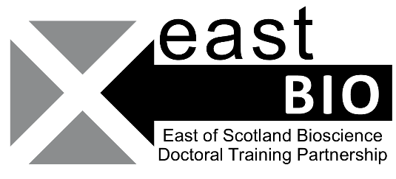
Thematic Research Training 2022-2023
Integrated Understanding of Health
Models for Bioscience
Queens Medical Research Institute, 47 Little France Crescent, EH16 4TJ
16th December 9:30-16:00
Session Description: This session is to gain insight into the wide spectrum of biological systems we can use in research ranging from animal models to organoids. Our speakers will cover some of the pros and cons of each and give us an insight into their own research. The session will include talks on three different model systems as well as a demonstration in the zebra fish facilities.
Session requirements: Nothing required specifically, you may want to bring a water bottle and a laptop.

Session Schedule
Times | Sessions (e.g. title, name of presenter, other details as necessary) | Venue/online link
10-11:00 | Organoid talk, Dr Duncan Rutherford | Wellcome Auditorium
11-12:00 | Drosophila talk, Dr Andrew Davidson | Wellcome Auditorium
12-14:00 | Lunch (Blue Sky Catering) + zebra fish demonstration | Wellcome Auditorium
14-15:00 | Mouse models talk, Dr Rebecca Gentek | Wellcome Auditorium

Travel & Access information The Queen’s Medical Research Institute (EH16 4TJ) is located at Little France campus (University of Edinburgh) which also contains the Royal Infirmary Edinburgh and the Royal Hospital for Children and Young People. Little France is easily accessible from the city centre (Edinburgh Waverly station). The best bus routes include the 8/33/49 which usually run from North Bridge or South Bridge every 15-20mins.
Local organisers, contact details: Broc Drury (b.drury@sms.ed.ac.uk) or 07825421197, Emma Dumble (edumble@ed.ac.uk) or 07724310054 and Haya Al Siyabi (H.Al-Siyabi@sms.ed.ac.uk )
Email EASTBIO at enquiries@eastscotbiodtp.ac.uk

