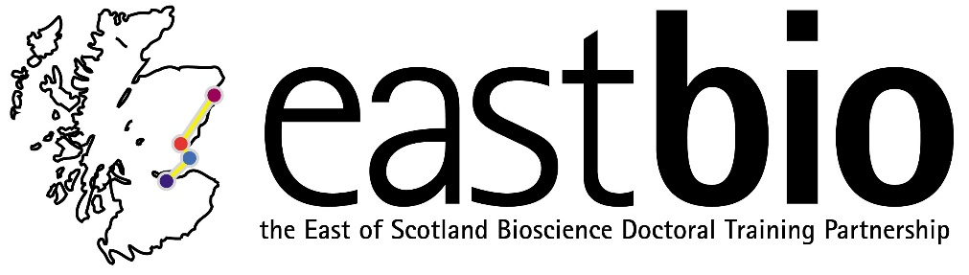
Science Communication
(for second-year EASTBIO students)
Workshop leader: Dr Ken Skeldon, Dr Lucy Leiper
Dates: 16-17 March 2017, in particular:
Thursday 16/3/17, 12:00-17:00, Macrobert (MR304)
Friday 17/3/17, 09:00-13:00, Macrobert (MR310)
Location: University of Aberdeen, Macrobert (building 17 on the map: http://www.abdn.ac.uk/about/documents/Old-Aberdeen-Campus-Map.pdf)
Workshop description: TBC
The workshops aim to help you develop core skills important for engaging the public with your research. This is becoming very important for research councils and funders and is a key element of a strong CV. During the session, participants will take part in different exercises to develop and refine communication skills, research messages and evaluation skills. Practical sessions will form the bulk of the course and follow-through opportunities will be presented, relevant to geographical regions across the EASTBIO University set.
Participants will put their newly developed skills into practice in a real live 'Speed Science' event which is part of British Science Week activities in Aberdeen. The ‘Speed Science’ event is a fast-paced communication session where participants will talk to the audience about their research.
During the course participants will:
- learn core communication skills necessary for engaging a public audience
- develop an understanding of the importance of public engagement in the modern research environment and the benefits for an academic or alt-academic career in and beyond the University
- learn key evaluations skills and how to embed them into public engagement events
- develop an awareness of local and national public engagement events through which participants can put new skills into practice.
For further info, please email enquiries@eastscotbiodtp.ac.uk

