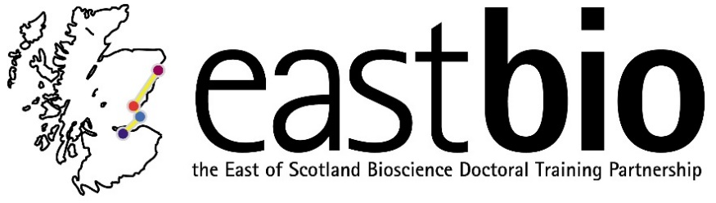

EASTBIO Research Training Strand 1 (2016-2017)
World Class underpinning Bioscience (WCUB) group

Third meeting: “Communication in Science”
28 March 2017, 10:00-16:00, St Andrews, Chemistry

Meeting Schedule:

10:00 - 10:30am Coffee and biscuits School of Chemistry Common Room

10:30 - 11:15am Kevin Jones Purdie Lecture Theatre D

11:15- 12:00pm Mhairi Stewart Purdie Lecture Theatre D

12:00 - 13:00pm Lunch Purdie Room 314

13:00 - 13:45pm Karen Spencer Purdie Lecture Theatre D

13:45 - 2:30pm Stefan Pulver Purdie Lecture Theatre D

2:30 - 3:00pm Coffee and biscuits School of Chemistry Common Room

3:00 - 4:00 pm ‘Talk to me, I’m a scientist’ School of Chemistry Common Room

