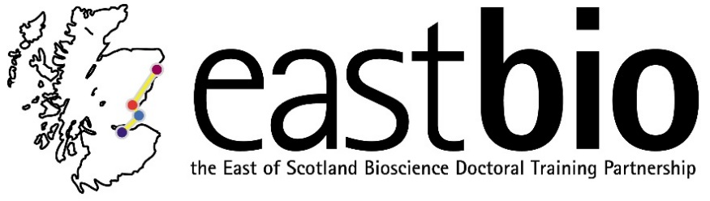
Thematic Research Training 2018-2019
World Class Underpinning Bioscience (WCUB) group
Chair: Dr Vicky MacRae
Session 1: “'Lies, damn lies, and statistics: A crisis in reproducibility?'” | Session 2: “Science communication and public engagement” | Session 3: “How we see the world: Introduction to vision and camouflage” | Session 4: “Mental health during PhDs”  Jointly with the IBB group
Session leaders (local organisers)  Host supervisors:  Ally Phillimore, Konrad Lohse  Student organisers:  Jamie Weir, Sam Ebdon | Session leaders (local organisers)  Host supervisors:  Julien Michel, Val Wilson, Thomas Becker, Sally Lowell  Student organisers:  Maria Kouridaki, Aaron Alonson Torrens, Louisa Drake, Matt French | Session leaders (local organisers)  Host supervisors:  Julie Harris, Jasna Martinovic  Student organisers:  Becky Maguire and Ana Rozman | Session leaders (local organisers)  Host supervisors:  Nicola Stanley-Wall, Ulrich Zachariae, Sally Lowell  u.zachariae@dundee.ac.uk  n.r.stanleywall@dundee.ac.uk  sally.lowell@ed.ac.uk  Student organisers:  Ryan Casement, Margarita Kalamara and Neil Thomson  r.casement@dundee.ac.uk; m.kalamara@dundee.ac.uk; njthomson@dundee.ac.uk
Programme available.  Date: 10 December 2018, 10:00-15:00  Location: Edinburgh (Ashworth, Honour Room 1, King’s Buildings)  . | Programme available.  Date: 13 February 2019, 9:30 (10:00 start)-15:00  Location: Edinburgh, Little France, Chancellors Building (Room FU224 – NRIE UoE Seminar Room 3 (Chancellors Building, 1st floor) | Programme available.  Date: 12 April 2019, 10:30-15:30  Location: St Andrews | Programme TBC  Date: 5 July 2019  Location: Dundee

