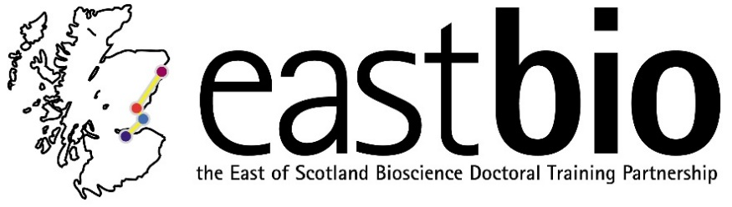
Thematic Research Training 2018-2019
World Class Underpinning Bioscience (WCUB) group
Chair: Dr Vicky MacRae
Session 1: “'Lies, damn lies, and statistics: A crisis in reproducibility?'” | Session 2: “Either science communication or bias” | Session 3: “Vision/camouflage” | Session 4: “Multidisciplinary approaches”
Session leaders (local organisers)  Host supervisors:  Ally Phillimore, Konrad Lohse  albert.phillimore@ed.ac.uk  Konrad.Lohse@ed.ac.uk  Host students:  Jamie Weir, Sam Ebdon  Jamie.Weir@ed.ac.uk  sam.ebdon@ed.ac.uk | Session leaders (local organisers)  Host supervisors:  Julien Michel, Val Wilson, Thomas Becker, Sally Lowell  julien.michel@ed.ac.uk  v.wilson@ed.ac.uk  thomas.becker@ed.ac.uk  sally.lowell@ed.ac.uk  Host students:  Maria Kouridaki, Aaron Alonson Torrens, Louisa Drake, Matt French  s1778943@ed.ac.uk  A.Alonso-Torrens@sms.ed.ac.uk  L.K.Drake@sms.ed.ac.uk  s1784229@ed.ac.uk | Session leaders (local organisers)  Host supervisors:  Julie Harris, Jasna Martinovic  jh81@st-andrews.ac.uk  j.martinovic@abdn.ac.uk  Host students:  Becky Maguire and Ana Rozman  rrm9@st-andrews.ac.uk  a.rozman.18@abdn.ac.uk | Session leaders (local organisers)  Host supervisors:  Ulrich Zachariae, Sally Lowell  u.zachariae@dundee.ac.uk  sally.lowell@ed.ac.uk  Host students:  Neil Thomson and Matt French  njthomson@dundee.ac.uk  s1784229@ed.ac.uk
Programme TBC  Date: 10 December 2018, 10:00-15:00  Location: Edinburgh (Ashworth, Honour Room 1, King’s Buildings)  . | Programme TBC  Date: February 2019  Location: Edinburgh, Little France | Programme TBC  Ideas – illusions, spectodiometry session, invite Ines Carthill and Nick ? on python programming of displays,  Date: April 2019  Location: St Andrews | Programme TBC  Ideas – how to set up collaborations? games, speakers  Date: June 2019  Location: Dundee

