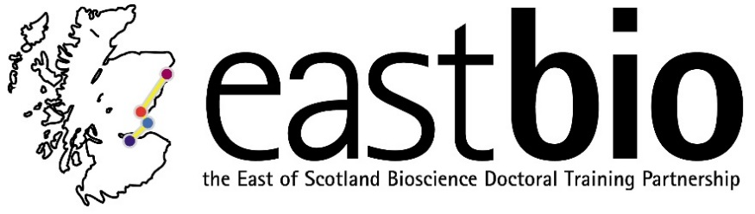
EASTBIO Research Skills Training 2017-2018
World Class Underpinning Bioscience (WCUB) group
Session 1: “Ethics” | Session 2: “CRISPR gene editing technologies” | Session 3: “Translation and impact of research”  Jointly with the BfH group | Session 4: “TBC”  Jointly with the BfH group
Session leader:  Stefan Pulver  Student organisers:  Courtney Aitken  Jacob Francis  with  Kyle Bennett  Jess Harvey-Cox | Session leader:  Paul Digard  Student organiser:  Susana Keane | Session leaders:  Hesse Constanze  c.hesse@abdn.ac.uk  Student organiser:  Karina Kangur  r02kk17@abdn.ac.uk | Session leaders:  Gerben van Ooijen  Gerben.vanOoijen@ed.ac.uk  & Robin Allshire  robin.allshire@ed.ac.uk  Student organisers:  Helen Feord  helen.feord@ed.ac.uk  &  Tadhg Devlin  Tadhg.Devlin@ed.ac.uk
Programme available.  Date: 4 December 2017, 10:00-15:00  Location: Old Library, School of Psychology & Neuroscience, University of St Andrews | Programme available.  Date: 23 February 2018, 10:30-16:00  Location: The Roslin Institute, Easter Bush campus, Edinburgh | Programme available.  Date: 20 April 2018, 10:30-16:00  Location: Aberdeen | Programme TBC.  Date: 13 June 2018  Location: Edinburgh

