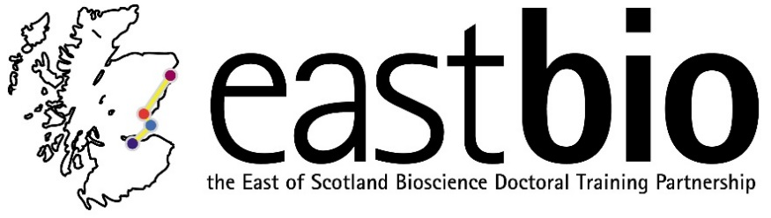
EASTBIO Research Skills Training 2017-2018
World Class Underpinning Bioscience (WCUB) group
Session 1: “Ethics” | Session 2: “Transparency, reproducibility, open access and big data” TBC | Session 3: “Translation and impact of research” | Session 4: “Public Engagement”
Session leader:  Stefan Pulver  sp96@st-andrews.ac.uk  Student organisers:  Courtney Aitken  cbaa@st-andrews.ac.uk  Jacob Francis @ jrjf2@st-andrews.ac.uk  with  Kyle Bennett  k.y.bennett@dundee.ac.uk  Jess Harvey-Cox  jlhc@st-andrews.ac.uk | Session leader:  TBC  Student organiser:  TBC | Session leaders:  Hesse Constanze  c.hesse@abdn.ac.uk  Student organiser:  Karina Kangur  r02kk17@abdn.ac.uk | Session leader:  Gerben van Ooijen  Gerben.vanOoijen@ed.ac.uk  Student organiser:  Helen Feord  helen.feord@ed.ac.uk
Programme TBC.  Date: 4 December 2017, 10:00-15:00  Location: Old Library, School of Psychology & Neuroscience, University of St Andrews | Programme TBC.  Date: February 2018  Location: Edinburgh | Programme TBC.  Date: April 2018  Location: Aberdeen | Programme TBC.  Date: June 2018  Location: Edinburgh

