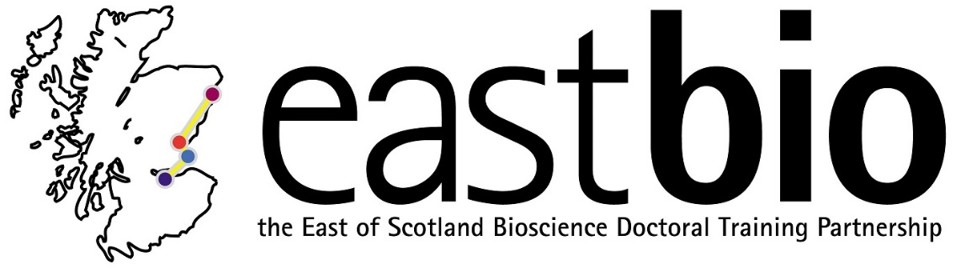

EASTBIO Transferable Skills Training 2018-2019

Presentation Skills Workshop

Video/filming instructions:

- Please ensure that you are in a quiet place and will not be disturbed
- You may wish to ask a friend or a colleague to film you
- A video camera would be ideal but a smart phone camera is sufficient
- Ensure that the camera/ phone is steady and not moving
- Make sure that the film captures the speaker, the slideshow and the audio
- Test it (especially the audio) beforehand to check that it works
- Ensure that you keep to time (10 minutes)

The film does not have to be a high quality production. It should, however, be easy to see the speaker, their slides and hear the audio clearly when played back.

Once you are happy with your video, upload it onto the Google drive folder via the link below (you will need to have a Google account before you can access the folder); make sure you save the file under your full name:

https://drive.google.com/drive/folders/1laHocFj9dvZ8d-Kqdf1bWS7lUa7R_5r8?usp=sharing

Deadline: 25 March 2019

If you have any further questions, please email Jo Young at joyoung21@gmail.com.

Training web-page:
http://www.eastscotbiodtp.ac.uk/year-1-foundation-training#presentation%20skills

