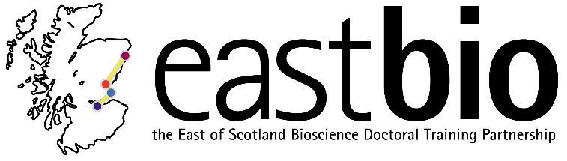
EASTBIO Annual Symposium:
“Research & Beyond: Four years of the EASTBIO experience”
University of St Andrews, Medical and Biological Sciences Building
13-14 June 2016
Day 1 – Monday 13 June 2016
Time | Session | Room
10:00-10:30 | Registration and coffee | xxx
10:30-10:40 | Welcome address  Rob Hardwick (BBSRC) | Lecture Theatre
10:40-11:50 | 2nd-year student talks (5 X 12 minutes talk) | Lecture Theatre
11:50-12:15 | Coffee break | xxx
12:15-13:00 | “Genetic control of mosquitoes”  Professor Luke Alphey (Pirbright Institute) | Lecture Theatre
13:00-13:45 | Lunch | Gateway Building
13:45-14:45 | 3rd-year poster sessions | xxx
14:45-15:55 | 2nd-year student talks (5 X 12 minutes talk) | Lecture Theatre
15:55-16:25 | Coffee break
16:25-17:30 | 2nd-year student talks (5 X 12 minutes talk) | Lecture Theatre
 | End of Symposium day 1
17.30 | EASTBIO management meeting | Seminar Room 1
19:30 | Dinner and Ceilidh | Lower College Hall, North Street

Day 2 – Tuesday 14 June 2016
9:00-9:30 | Late registration and coffee |  | xxx
9:30-11:00 | 1st-year student talks |  | Lecture Theatre
11:00-11:30 | Coffee break
11:25-12:05 | “Perception and Memory as experienced within an Arts/Science collaboration”  Professor Nicola S. Clayton (University of Cambridge) with artist Clive Wilkins |  | Lecture Theatre
12:05-12:50 | Lunch |  | Gateway Building
12:50-14:00 | 4th-year student panel discussion | Supervisors & EASTBIO team discussion | Lecture Theatre  Seminar Room 1
14:00-15:10 | 2nd-year student talks (5 X 12 minutes) |  | Lecture Theatre
15:10-15:40 | Coffee break |  | xxx
15:40-16:40 | 3rd-year student poster sessions |  | Lecture Theatre
16:40-17:15 | Wine & nibbles reception, followed by prize-giving |  | xxx
17:30 | Symposium close

