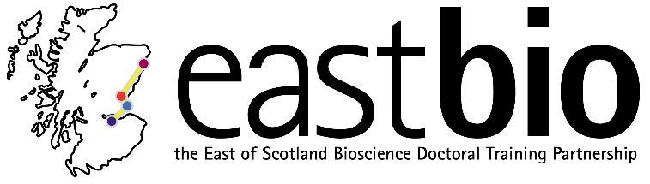
EASTBIO Annual Symposium
13-14 June 2016
University of St Andrews, Medical Science Building, The Gateway
Day 1 13 June 2016
Time | Session | Room
10:00-10:30 | Registration and coffee
10:30-10:40 | Welcome address  Rob Hardwick (BBSRC)
10:40-11:40 | 2nd-year student talks (5 X 12 minutes talk)
11:40-12:15 | “Genetic control of mosquitoes”  Professor Luke Alphey (Pirbright Institute)
12.15-13:00 | Lunch
13:00-14:00 | 3rd-year poster sessions
14:00-15:30 | 2nd-year student talks (7 X 12 minutes talk)
15:30-16:00 | Coffee break
16:00-17:30 | 2nd-year student talks (7 X 12 minutes talk)
17:30 | End of Symposium day 1
Evening | Dinner and Ceilidh

Day 2 14 June 2016
9:00-9:30 | Late registration and coffee
9:30-11:00 | 1st-year student talks
11:00-11:30 | Coffee break
11:25-12:05 | “Perception and Memory as experienced within an Arts/Science collaboration”  Professor Nicola S. Clayton (University of Cambridge) with artist Clive Wilkins
12:05-12:50 | Lunch
12:50-13:30 | 4th-year student panel discussion | Supervisors & EASTBIO team discussion
13:30-14:30 | 2nd-year student talks (5 X 12 minutes)
14:30-15:00 | Coffee break
15:00-16:00 | 2nd-year student talks (5 X 12 minutes)
16:00-17:00 | 3rd-year student poster sessions
17:00-17:30 | Wine & nibbles reception, followed by prize-giving
17:30 | Symposium close

