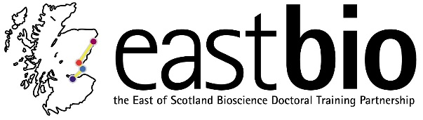

Research Symposium
University of Dundee, 13-14 June 2019
Dundee, Dalhousie Building
Day 1
10:30 | Registration & coffee/tea | The Street, School of Life Sciences
11:00-11:10 | Welcome & Introduction  Dr Edgar Huitema & student reps | Dalhousie, Lecture Theatre
11:10-11:40 | Welcome/Keynote address  Dr Rob Hardwick/ or BBSRC rep | Dalhousie, Lecture Theatre
11:40-12:15 | Speed-dating  Chair/s: Amy Cooper/Meg Peyton Jones | Dalhousie
12:15-13:00 | Poster session | Dalhousie, Room 1S01
13:00-14:00 | Lunch & coffee/tea | The Street, School of Life Sciences
14:00-15:45 | Student talks I: Genetic Processes & Proteins (parallel session)  Professor Chris Ponting (MRC Institute of Genetics & Molecular Medicine, University of Edinburgh) | Dalhousie, Lecture Theatre
14:00-15:45 | Student talks II: Environmental Biology & Ecology (parallel session)  Professor Colin Moffat (Marine Scotland) | Dalhousie, Room 1F06
15:45-16:00 | Coffee/tea break
16:00-17:30 | Student talks III: Health & Nutrition (parallel session)  Dr Alison McNeilly (School of Medicine, University of Dundee) | Dalhousie, Lecture Theatre
 | Student talks IV: Fundamental meets Synthetic Biology (parallel session)  Dr Peter Murray-Rust (Department of Chemistry, University of Cambridge) | Dalhousie, Room 1F06
17:30 | Close of day 1.  Check-in at West Park Conference Centre  EASTBIO Coach available for all attendees | West Park Conference Centre
19:00 | EASTBIO Dinner, followed by a Ceilidh dance | Best Western Queens Hotel (city centre)
Day 2
9:30 | Welcome & Late registration | The Street, School of Life Sciences
10:00-10:10 | Introduction  Chair/s: Student reps | Dalhousie, Lecture Theatre
10:10-12:00 | Student talks V: Body, Brain & Behaviour (parallel session)  Professors Nicola Clayton (Department of Psychology, University of Cambridge) and Clive Wilkins (Co-founder of The Captured Thought, Artist in Residence, Department of Psychology, University of Cambridge) | Dalhousie, Lecture Theatre
10:10-12:00 | Student talks V: Body, Brain & Behaviour (parallel session)  Professor Gernot Riedel (Institute of Medical Sciences, University of Aberdeen) with Dr Carole Torsney (Centre for Discovery, Brain Sciences, University of Edinburgh) | Dalhousie, Room 1F06
12:00-13:00 | Lunch & coffee/tea | The Street, School of Life Sciences
13:00-13:40 | Science Pub Quiz | Dalhousie, Lecture Theatre
13:40-14:00 | Coffee/tea break | The Street, School of Life Sciences
14:00-15:30 | “Career paths, career stories” (panel discussion)  Dr Tim George (James Hutton, Dundee), Dr Eleanor Gaunt (Roslin, Edinburgh), Professor Chris Ponting (Edinburgh), Prof Gernot Riedel (Aberdeen), Dr Ben Rutter (Cambridge), Dr Magali Sivakumaran, Dr David Walker (Glasgow) | Dalhousie, Lecture Theatre
15:30-16:00 | Prize-giving; concluding remarks & close of symposium  Dr Edgar Huitema & student reps | Dalhousie, Lecture Theatre

