Foundation Masterclasses 2022-2023
Structural Biology & Crystallography
Optional for first- and second-year EASTBIO PhD students
Workshop leader: Dr Chris Harding (University of St Andrews)
3rd May 2023, 10:30-16:00
Venue: Teaching Lab, Room 205, Biomolecular Sciences building, North Haugh, St Andrews (see below for some travel guidance)

Workshop description:
A short course looking at the practical experimental aspects of protein x-ray crystallography and generating structural figures suitable for publication.

This course will be a whistle-stop introduction to the crystallography side of structural biology. No previous experience is necessary (though a little background reading would help with terminology). The workshop will swiftly move on from a brief introduction to the more practical aspects of protein crystallization, collecting X-ray diffraction data, solving a macromolecular structure, looking at amazing structures in the Protein Data Bank (PDB), how to generate those lovely figures that you see in publications, and what information we would typically describe and derive from a macromolecular structure.

Learning outcomes:
- What do we use macromolecular structural information for?
- The variables in crystal growth optimization; how to collect usable diffraction data.
- Appreciate the variety of software required for protein structure solution and refinement; how to find and look at structures in the PDB; how to generate publication quality images.

Training Schedule:

10:30-11:00 | Welcome and introduction to protein crystallography  Coffees/Teas/Pastries
11:00-11:40 | Protein crystallization (Lysozyme – hands on practical)
11:40-11:50 | Break
11:50-12:30 | Data collection, solving structures (phenix – MR, computer practical)
12:30-13:30 | Lunch break
13:30-14:30 | Structure building and refinement (coot & phenix - computer practical)
14:30-14:45 | Break for coffee/tea/snacks or fruit
14:45-15:15 | Structure building and refinement (coot & phenix - computer practical) - continued
15:15-16:00 | Hands-on practical using Chimera to generate publication quality images & check crystals plates / loop crystals? (lysozyme)

Participation requirements:
- Prior to the workshop, students should download the CCP4 Molecular Graphics package (https://www.ccp4.ac.uk/MG/), Phenix (https://phenix-online.org/download/) & ChimeraX (https://www.cgl.ucsf.edu/chimerax/download.html). A sample structure file will be sent out closer to the course data for analysis.
- Some basic background reading on crystallography would help with understanding terminology.

Training web-page: http://www.eastscotbiodtp.ac.uk/foundation-masterclasses

Travel information:

Venue – map info

If you are coming by train, stop at Leuchars and take the bus to St Andrews. Bus @99 is very convenient as it stops right by the University; see screenshot of bus stop in relation to the Biomedical Sciences building, below.

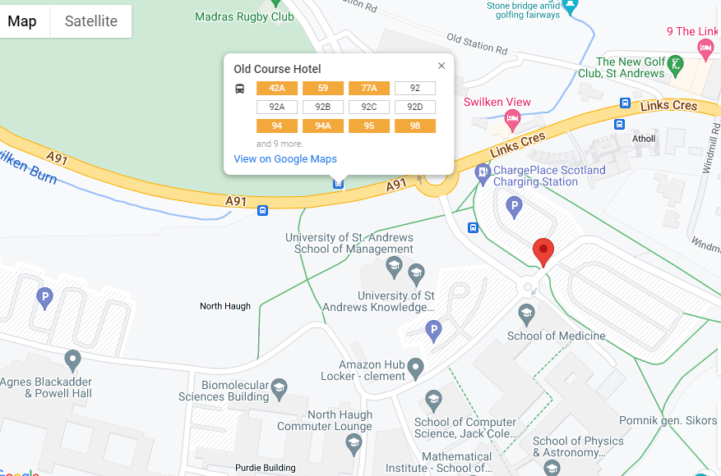

If you drive to St Andrews, see parking information here. Petheram Bridge Car Park is the largest and closest to the Biomolecular Sciences building. Please consider a car pool with fellow EASTBIO students, if convenient.

For any questions about this training, please email enquiries@eastscotbiodtp.ac.uk

