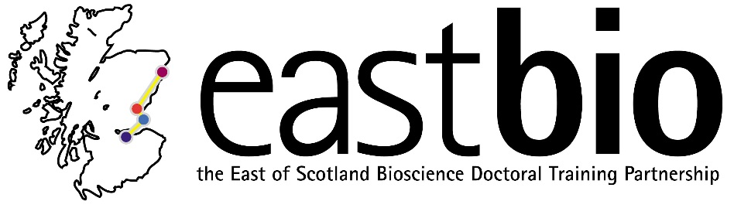

EASTBIO DTP Training Day

Statistics and Experimental Design course
29 September 2015, Dundee, 09:00-13:00

Course leader: Dr Margo Chase-Topping (Centre for Immunity, Infection and Evolution, University of Edinburgh)

Course outline

Time | Description
0900-0945 | Developing scientific questions
0945-1000 | Break
1000-1045 | Designing methodology
1045-1100 | Break
1100-1300 | Analysing data:  - Database construction  - Choice of Statistical package  - Exploratory Data Analysis (EDA)

For further information, please email enquiries@eastscotbiodtp.ac.uk

