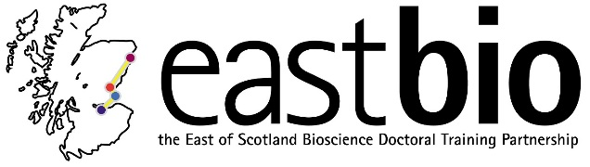

NPIF Skills School
‘Broadening Horizons: Cultivating an Innovative Mind Set’

Edinburgh, John MacIntryre Conference Centre and Playfair Library
Monday 4 – Tuesday 5 June 2018

This skills school “Broadening Horizons: Cultivating an Innovative Mind Set” has been developed by the BBSRC EASTBIO DTP and the BBSRC IBioIC CTP in partnership and close collaboration with 5 industry facilities: the IBioIC Flexible Downstream Bioprocessing Centre, Edinburgh (FlexBio); the National Phenotypic Screening Centre, Dundee; BioAscent / the European Screening Centre, Biocity, Newhouse; the Edinburgh Genome Foundry; and the Roslin Cell Therapies Ltd GMP facility, Edinburgh. It draws on expertise and know-how from these complementary partners to address industry-identified needs and skills gaps.

Event website:
https://www.ed.ac.uk/biology/current-students/early-career-researchers

What participants can expect
We have reached out to the broader research and user community and PhD students and postdocs from the following programs will be attending:
- BBSRC EASTBIO DTP students
- IBioIC CTP students and postdocs
- EPSRC MRC CDT in Optical Medical Imaging students
- MRC Precision Medicine Doctoral Training Programme
- EPSRC CDT in Data Science students
- EPSRC CDT in Intelligent Sensing and Measurement
- Postdocs across Scottish Universities prioritising BBSRC-funded
We hope the programme will initiate academia-industry links that may inform future research directions, build links between the training partnerships that will translate into future training offers, and link DTP and CTP cohorts with expected impact on future career and trajectories.

Skills School objectives are to:
- Provide a clear understanding of the UK Bioscience/Biotechnology, Leading Edge Healthcare and Accelerating Therapeutics sectors, including current research and innovation challenges, through direct engagement with senior industry professionals.
- Raise awareness of career opportunities and trajectories, how skills gained in doctoral/postdoctoral training could transfer into, and what additional skills would be required for competitive entry into, a range of industry careers.
Stimulate inter-disciplinary thinking, inform and facilitate career choices and initiate professional networks.
- Familiarise delegates with opportunities, and train them in specific procedures and standard practice in an industry sector related to their research or career ambitions.

Programme
Event Schedule for Day One: Monday 4 June 2018:

11:00 to 11:30 | Arrival at John McIntryre Conference Centre (JMCC) and registration (please report to the JMCC reception)
11:45 to 12:00  12:00 to 13:00 | Welcome overview to the Skills School from EASTBIO and IBioIC  Introductory plenary Steve Rees, Astra Zeneca (Introduced by Dr Paul Andrews)
13:00 to 14:00  14:00 to 17:30 | Lunch  PLEASE SEE INDIVIDUAL SCHEDULE FOR DETAILS OF PARTICIPANTS SELF SELECTED MASTERCLASS YOU WILL BE ATTENDING  Participants who selected training at Masterclass based at the NPSC or Bioascent facilities will remain in the JMCC Conference Centre.  Participants who selected Masterclass will be based at one of the Edinburgh facilities RoslinCT, Flexbio or Edinburgh Genome Foundry.
19.00 to 21.30 Dinner and networking for all participants

21.30 Overnight accommodation

Event Schedule for Day Two: Tuesday 5 June 2018:

07:00 to 17:30  17:30 to 18:15 | PLEASE SEE INDIVIDUAL SCHEDULE FOR DETAILS OF PARTICIPANTS SELF SELECTED MASTERCLASS YOU WILL BE ATTENDING  Participants will be based at the respective facility for hands on training for their self-selected Masterclass. This will be based at one of the following venues: RoslinCT, Flexbio, Edinburgh Genome Foundry, NPSC or Bioascent.  Drinks reception with finger buffet
18:15 to 18:45 | Summary feedback of the key learning points from each masterclass (Introduced by Dr Ian Archer)
18:45 to 20:00 | Closing plenary from Steve Martin GSK with questions from the floor (Introduced by Prof Clare Blackburn)
20:00 | Close of event (Taxi to JMCC Conference Centre for optional overnight accommodation)

Speaker Biographies
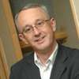
Steve Rees, Vice President, AstraZeneca
Steve is currently Vice-President of Screening Sciences and Sample Management at AstraZeneca with global responsibility for High Throughput Screening, Compound Management, the human tissue BioBank and the provision of SAR biology support to preclinical discovery projects. Prior to joining AstraZeneca, Steve worked at GlaxoSmithKline for 24 years in various roles including that of Director of the Screening and Compound Profiling Department at GlaxoSmithKline in Stevenage. Steve has been responsible for developing hit identification, compound profiling and compound management strategies for Astra Zeneca and previously GlaxoSmithKline. Steve has led multiple international collaborations and has sponsored the development and implementation of a range of cellular assay technologies for ion channel, GPCR and other target classes.

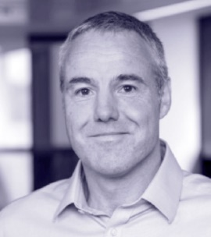
Stephen Martin, Vice President and Head of Biopharma Molecular Discovery at GSK.
Steve is VP and Head of Biopharm Molecular Discovery at GlaxoSmithKline, responsible for the creation of new biopharmaceutical medicines in therapy areas including oncology, immune-inflammation and respiratory disease. His team develop and apply cutting edge technology to improve the lives of patients, with inhaled biologics and bispecific antibodies for example. Steve collaborates with technology and therapy area experts inside and outside GSK, and has successful partnerships with academic institutions and biotech companies across the globe. He has over 20 years pharma R&D experience in small molecule and biopharmaceutical drug discovery. Steve has a Chemistry degree and a Ph.D. in molecular biology from the University of Oxford.

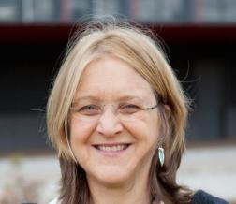
Prof Clare Blackburn (EASTBIO DTP)
Clare is the Director of the EAST of Scotland Doctoral Training Partnership and Professor of Tissue Stem Cell Biology of MRC Centre for Regenerative Medicine, University of Edinburgh. She also has a strong interest in public engagement and coordinates the EuroStemCell project. Her academic research lab studies the mechanisms through which the thymus – a central organ of the immune system - develops and is maintained, with a particular focus on regulation of epithelial progenitor/stem cells in the fetal and adult organ. The overall goal is to develop effective cell replacement or regenerative protocols for boosting thymus function, in order to stimulate T cell production in patients. This could improve the treatment of immunodeficiencies caused by disease or normal aging, or associated with solid organ or bone marrow transplantation or cancer therapy, and for treating congenitally athymic patients.

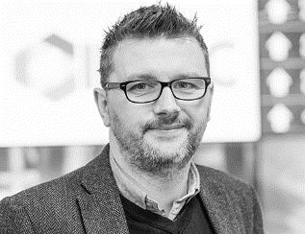
Dr Ian Archer (IBioIC CTP Director)
Ian joined IBioIC as Technical Director in August 2015 and is tasked with shaping the IBioIC's strategy and implanting the business plan for the centre. Specifically, he identifies mechanisms, resources and techniques for solving industry problems through biotechnology.
Having received his degree and PhD in Chemistry from Imperial College, London, Ian spent six years working as a Work Group Leader in Process Technology with Zeneca (latterly Avecia) in Grangemouth, Scotland. With a firm background in synthetic organic chemistry and chemical process development, in 2004, Ian joined Ingenza Ltd. as Head of Process Development where he was responsible for all aspects of bioprocess development and developed his expertise at the interface of molecular biology, microbiology and bioprocess development. He is an Honorary Lecturer in the School of Chemistry at the University of Edinburgh.

Dr Paul Andrews (Director of Operations, National Phenotypic Screening Centre)
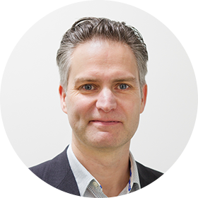
Paul gained a BSc. Honours Degree in Biochemistry in 1987 and a Ph.D. in Molecular Biology in 1991 both from the University of Sheffield, UK. After a short postdoctoral position in infertility research, Paul moved to Dundee in 1993 to take up a series of postdoctoral positions with Michael Stark exploring the molecular genetics and cell biology of key yeas protein phosphorylation pathways. Paul established and ran a deconvolution microscopy facility for a few years then took up a senior postdoctoral position in the lab of Jason Swedlow studying Aurora B kinase. Paul was recruited to the Drug Discovery Unit in Dundee in 2007 to establish a high content screening platform and was team leader in an interdisciplinary but highly commercially-focused academia industry consortium, pioneering the industrial application of phenotypic screening to identify small molecules that seer stem cell fate. Paul was subsequently recruited to a team leader position at the stem cell company Cellartis AB, funded by Novo Nordisk, to develop chemical tools, reagents and protocols for type-I diabetes cell therapy. In 2012 Paul established a consultancy company, Stem Cell Solutions Ltd, and since 2013 has been working with the Scottish Universities Life Science Alliance to create and subsequently run the National Phenotypic Screening Centre.

Parking
Free onsite parking is available at the Pollock Hall venue on Day 1 which participants can request when they reach the security gate. For the Playfair Library on Day 2, participants will be required to find and pay for their own parking (on street and central location). If you are staying overnight, there is the potential to be parked at Pollock Halls for both days and return on Day 2 without charge; however, this is a 20 minute walk away form the Playfair Library. Please bear in mind that public transport should be utilised where available as there will be limited availability of parking.

Location
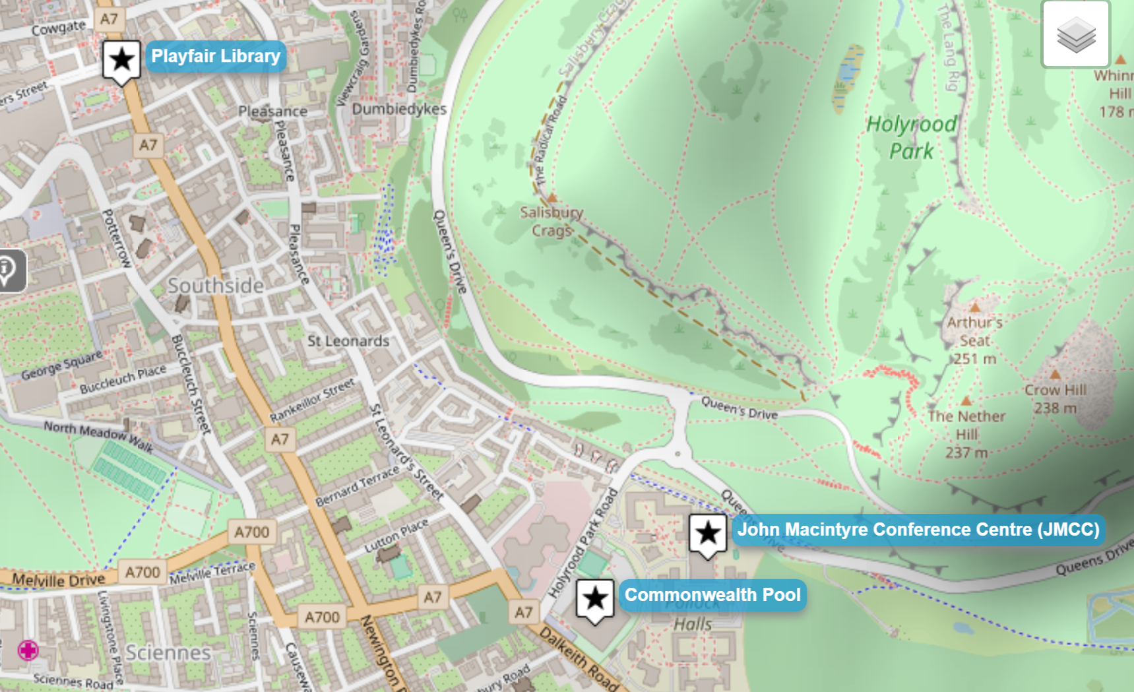
Edinburgh Waverly to JMCC (walking): 30 mins
Playfair Library to JMCC (walking): 20 mins

