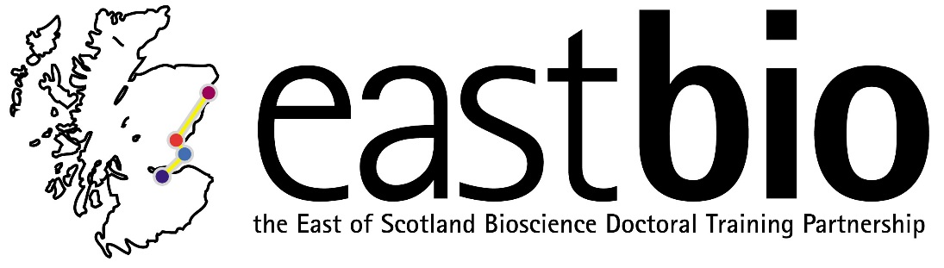
EASTBIO DTP Foundation Masterclasses
Training Strand 2: Bioscience Skills

Proteomics and Mass Spectrometry
Course leader: Dr Sara Ten Have (Centre for Gene Regulation and Expression, University of Dundee)
Date: 20 May 2016, 09:00-17:00
Venue: Dalhousie 2F15, University of Dundee
This course will cover the fundamental principles of how a mass spectrometer works and how mass spectrometry is used in everyday life as well as the technique’s developmental history. Experimental techniques used for proteomics analysis will be covered, for example commonly used experimental designs, labelling strategies and enrichment of specific peptides. Participants will learn how to access on-line protein databases and their use in proteomics work. Participants will also learn basic spectral annotation, peptide spectral annotation, data screening and interpretation in several workshops throughout the day, and will be provided with some software which will aid in these exercises (MaxQuant, Perseus and DataShop).
Overall, this course will provide participants a strong foundation in the principals of proteomics and equipped them with the knowledge to apply this technology to their own scientific questions.
Requirements: All participants are requested to bring a laptop computer.
For info, please email enquiries@eastscotbiodtp.ac.uk

