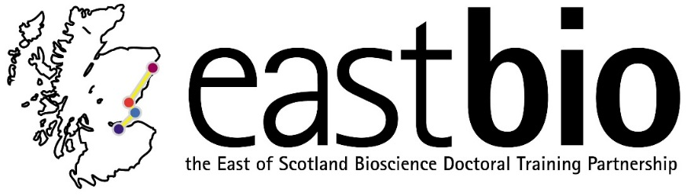
EASTBIO DTP Foundation Masterclasses 2018-2019
Proteomics and Mass Spectrometry
Course leaders: Douglas Lamont, Amy Tavendale and Kelly Hodge
Date: 24 May 2019, 09:00-17:00
Venue: Small Lecture Theatre, MSI building, Life Sciences, Dundee (no 21 on the campus map, below)
Please note: Students are asked to arrive at the CTIR reception (no 49 on the campus map, below), where they will be taken to the Lecture Theatre. Make sure you arrive promptly at 9:00 to enable a smooth running of the workshop.
Summary:
To improve our ability to identify proteins, elucidate structure and function, new technologies such as proteomics and mass spectrometry have been developed and advanced over the last few decades. These technologies have and are being used to solve a wide range of problems in biochemical research from confirmation of protein identity, through detailed analysis of chemical modifications on proteins, to measurements in relative expression differences between protein populations.
This course will cover the fundamental principles of how a mass spectrometer works and how mass spectrometry is used in everyday life as well as the technique’s developmental history. Experimental techniques used for proteomics analysis will be covered, for example commonly used experimental designs, labelling strategies and enrichment of specific peptides. Participants will learn how to access on-line applications and protein databases to use in their proteomics work. Participants will also learn how to analyse and interpret quantitative mass spectrometry data using software that is freely available (MaxQuant and Perseus) in several practical workshops throughout the day. A tour of the FingerPrints Proteomics Facility is also included to provide an overview of what a busy core proteomics facility does and to show real mass spectrometry systems in operation.
Overall, this course will provide participants a strong foundation in the principals of proteomics and equipped them with the knowledge to apply this technology to their own scientific questions.
Schedule:
9.30-10.45 | Seminar - Introduction to Mass Spectrometry
10.45-11.05 | Coffee/tea break (WTB Atrium)
11.05-12.20 | Seminar - Introduction to Mass Spectrometry
12.20-13.05 | Lunch (WTB Atrium)
13:05-13:50 | Tour of Proteomics Facility (CTIR Mezzanine Level)
13:50-15.05 | Seminar - Introduction to Quantitative Proteomics
15.05-15.25 | Coffee/tea break (WTB Atrium)
15.25-17.00 | Practical (MaxQuant)

Requirements: All participants are requested to bring a laptop computer, ideally with a windows operating system that allow them to access the local network via wifi.
EASTBIO may provide some of the masterclass materials after prior communication with the leaders and upon request by students who are unable to attend.
For any queries, email the masterclass leader at d.j.lamont@dundee.ac.uk or enquiries@eastscotbiodtp.ac.uk.

