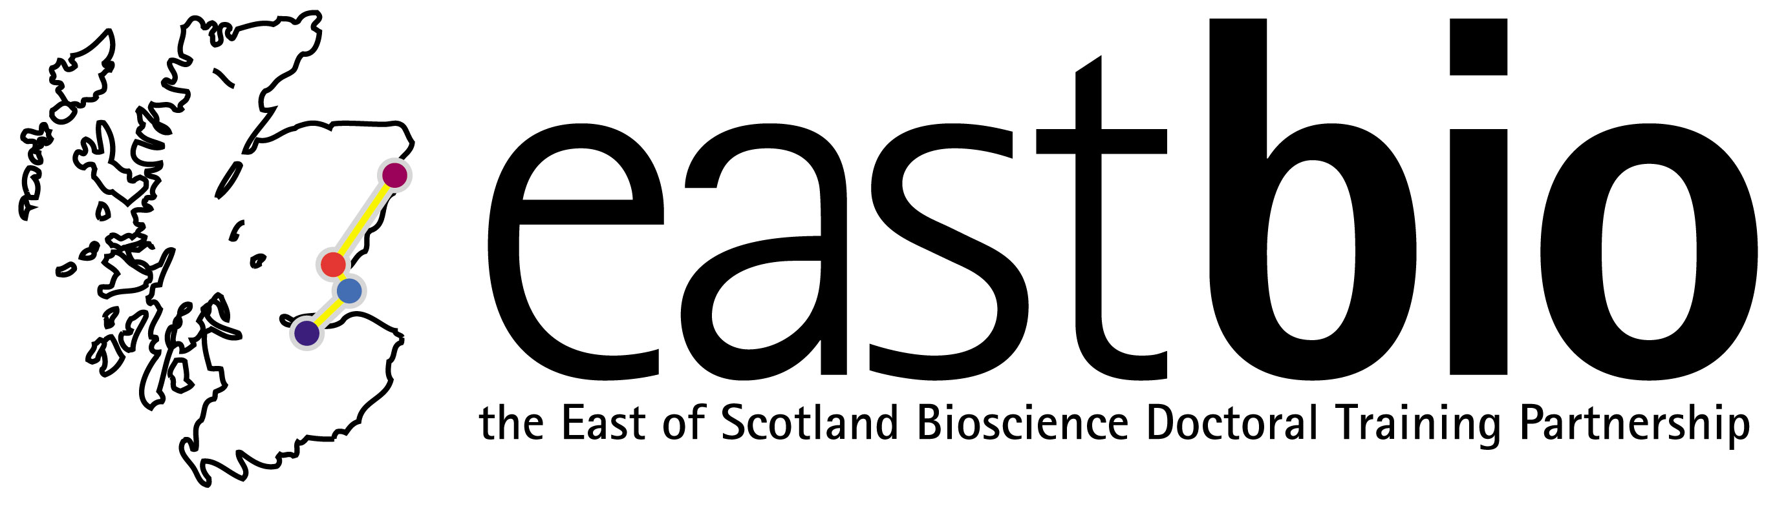

EASTBIO Transferable skills 2019
Presentation skills course (first-years only)

This course has two components:

- Students will video record themselves giving a 10 minute talk then they will submit the video to EASTBIO (videos will be kept private). The video will then be viewed and each individual will receive feedback in writing specifically tailored to them. The feedback will be sent in advance of the final presentation day.

- Students can then adjust and rehearse their presentations based on the feedback so that they are ready to present to a group of academics. They will also take part in a two hour class training session prior to giving their presentations on the 8th March.

Timeline

- December/ January: Students video record themselves giving a ten minute talk

- 30th January: Students submit their videos to EASTBIO

- 23rd February: Students receive individual feedback on their videos & prepare their final talks

- 3 May: 2 hour class workshop followed by final presentations

Workshop summary
Researchers are frequently under pressure to communicate their information verbally, whether it is an oral presentation, in a group meeting or an interaction at a conference. Performing well in a keynote presentation or impressing at a chance meeting is important for facilitating collaborations and building relationships with future employers. Public speaking is a key component to a successful career, both within academia and beyond.
This workshop will cover various situations that researchers are faced with regularly with regard to presentations. We will cover oral presentations, how to get the most from your poster session at a conference and how to pitch your research. Effective verbal delivery and engagement takes practice and participants will be introduced to various techniques that they can use and adapt to a variety of situations. We take a step by step approach to presentations, building up from initial short research pitches to longer conference talks so participants can gain confidence.
Prior to the workshop, all participants are required to submit a video of themselves delivering a 10 minute talk on their research project. This will be viewed and individual feedback will be provided (in writing) so that participants can apply it when designing their actual talks that will be delivered to EASTBIO academics in March.

Workshop content – 3 May

- Introduction to presentations
- Short communications
- Oral presentation design & delivery
- Figures and information visualisation
- Group exercise

Workshop schedule 3 May (Room 7.15, Swann building, King’s Buildings, Edinburgh; based on two groups of ~19 participants)

10:00-12:00: Workshop for first group
12:00-13:30: Lunch and coffee/tea
1:30-15:00: Workshop for second group
1:30-15:00: First group presentations
15:00-17:00: Second group presentations

