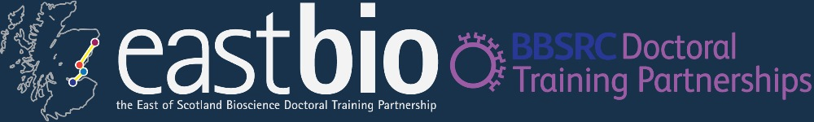

Bioenergy and Industrial Biotechnology Research Theme
Session 2
Synthetic Biology Workshop
10:00-16:30 9th February 2015
University of Dundee
Life Sciences CTIR building
Room MR 284

Time | Presentation
10:00-10:10 | Introduction – Holly Corrigall and Matt Dale
10:10-10:45 | Synthetic Biology Paper Reviews  Each pair of students to give 10 min presentation reviewing a synthetic biology paper from the literature.
10:45 – 11:00 | Coffee Break
11:00 – 13:00 | Copasi Workshop  Introduction to Copasi software for defining and analysing systems biology models. Please bring your laptops.
13:00-14:00 | Lunch
14:00-15:00 | Overview of synthetic biology used in iGEM projects 2014.  Speakers: Prof Frank Sargent (University of Dundee) and Prof Ian Stansfield (University of Aberdeen)
15:00- 15.15 | Coffee Break
15:15 – 16:15 | ‘iGEM in an Hour’ Competition
16:15 – 16:30 | iGEM Presentations

