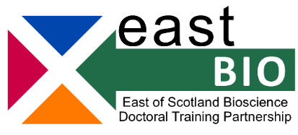

EASTBIO Transferable Skills Training 2020-21
Making the Most of your Final Year
For third- and fourth-year EASTBIO students
Workshop leader: Dr Jo Young
Date: 11 November 2020, 09:30 (10:00 start)-16:00
Location: this training will be delivered online; the link will be circulated directly to students via email.
Workshop description:
Have you decided on your next career steps after your PhD? Are you feeling confident about the transition into your next role? Have you made the most of the opportunities on offer in EastBio and beyond? Are you prepared for your final year and have you planned appropriately for it?
This session is designed to give you the tools to maximise the opportunities an EastBio PhD offers and increase your employability on graduation. We'll look briefly at the range of opportunities available to bioscience researchers, then work through a career planning process to help you use your doctoral studies as a route into the career of your choice. During their career, researchers develop a number of skills that they can utilise in a variety of other positions, whether these are related to their research or not. We'll explore these skills and employer needs (both in and beyond academia) and look at what you need to do to be able to offer the right skills and experiences when you make the transition to the next stage of your career.
Learning outcomes:
By the end of the workshop you will have:
- discussed the challenges you expect in your final year and made plans for how you intend to project manage it;
- an understanding of the steps you should take to plan your career;
- an awareness of the opportunities available to develop your employability during a PhD;
- an understanding of the value of networks and how you can make yourself visible;
- an understanding of the skills you have and those that you would like to develop further.
Schedule
10:00 | Session 1
11:30 | Screen break
11:45 | Session 2
13:00 | Screen break
1340 | Session 3
15:00 | Screen break
15:10 | Session 4
16:00 | Finish

Participant requirements:
Although there are no pre-workshop requirements, you may find it useful to have a copy of your CV handy to refer to during the day and to help you identify your next steps.

EASTBIO training web-page: http://www.eastscotbiodtp.ac.uk/year-3-professional-training
If you have further questions, please email enquiries@eastscotbiodtp.ac.uk.

