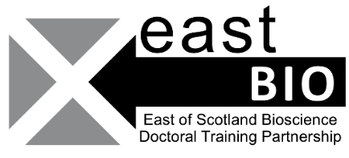
Thematic Research Training 2020-2021
Livestock and Aquaculture group
Session 1: “Alternative meat”
Online, 11 December 2020, 12:00-16:30
Session Description
Increasingly consumers choose vegetarian and vegan alternatives for meat and seafood. Consequently, the market for alternative meat and seafood is growing rapidly. How do these trends influence the livestock and aquaculture industry? What will be the economic and ecologic impact of these changes?
This event will consist of four presentations by academics and specialists who work within or in close contact to the field of food security. The aim is to offer a glimpse into a variety of approaches currently available or still in development that offer a potential alternative to animal-based protein sources.
Session Schedule:
Times | Sessions
12:00-12:10 | introduction  Alexandra Florea
12:10-12:40 | Prof. Sam Martin (University of Aberdeen)
12:40:12:55 | Questions Prof. Sam Martin
12:55-13:25 | Dr Richard Freeman (Commercial Manager-Roslin Technologies)  Prof Jacqui Matthews (Chief Technology Officer) or Dr Karen Fairlie-Clarke (Innovation & Engagement Manager)
13:25-13:40 | Questions Roslin Technologies
13:40-14:10 | Lunch Break
14:10-14:40 | Jeroen Willemsen (Green Protein Alliance)
14:40-4:55 | Questions Jeroen Willemsen
14:55-15:25 | Roline Broekema (Blonk Consultants)
15:25-15:40 | Questions Roline Broekema
15:40-16:10 | General Discussion-Bringing it all together (Breakout rooms)
16:10-16:20 | End of seminar

Local organisers & contact details:
- Emily Charlton - e.m.charlton@sms.ed.ac.uk
- Alexandra Florea - alexandra.florea@ed.ac.uk
- Bjorn Kok - bjorn.vitali.kok@gmail.com

