Bring an Intern on Board Form

*Please return this form completed, to propose a professional internship, to the PIPS Coordinator.*

**Email:** [dtp@sulsa.ac.uk](mailto:dtp@sulsa.ac.uk)

### ****Address:**** Scottish Universities Life Sciences Alliance (SULSA), Darwin Building Room 309, King’s Buildings, University of Edinburgh, Edinburgh EH9 3JF

The Biotechnology and Biological Sciences Research Council (BBSRC) is offering an exciting opportunity for **any non-academic organisation** to take advantage of fully funded Professional Internships for PhD Students (PIPs). These three month professional internships can be in any field or sector.

**Internship roles**:

Something that is clearly important to the organisation. Ideas could include, but are certainly not limited to:

* researching new development ideas or products (but not within an academic or research institute)
* creating a marketing, publishing or sales campaign
* a business development project
* managing a specific project
* developing teaching/science communication materials
* improving a specific policy or working in a setting related to policy (e.g. government department or charity)

**Benefits for a business taking on a PhD intern:**

* A high-calibre temporary resource to assist with a strategic project
* Extra support at no cost as PIPS students are fully funded by the University through their PhD salary
* Resource to undertake projects that might have been on hold/will not otherwise be done
* Involvement with intelligent minds that bring innovation, skills and knowledge to benefit your business success and performance
* Opportunities to get energy and fresh insights to a particular business area; a different perspective to problems, and a new motivated member of the team

**Benefits for PhD students:**

* A chance to try out a particular professional area; to test career goals and get an idea of what a job really involves. This will help students make informed career choices in the future and dispel any misconceptions
* An opportunity to develop employability by learning through high-quality work experience in a non-academic setting

**Cost:**

* This professional internship is funded by the BBSRC as part of the PhD, with students continuing to receive their PhD stipend as normal, so there are no tax implications for your organisation
* If the student lives more than 50 miles from the organisation we encourage a contribution from your organisation towards their travel or accommodation costs

**Timescale:**

* 12 weeks in a single block or multiple shorter blocks
* Flexible – anytime so you can make them a part of your business priorities

**Requirements:**

* A challenging internship project with clearly defined task/s – either one big project or the workload could be spread across a number of areas to give as much diversity in work as possible
* Work space and equipment
* An experienced employee who will act as a mentor to support the PhD intern. The mentor is responsible for the induction process, supervising the delivery of a piece of work, providing training, feedback, encouragement and is the designated point of contact for the PIPS Coordinator.
* Interns need to be included in team/departmental meetings, training and ad-hoc events as appropriate.

**Designing an internship project:**

* PhD interns have the potential to make a huge contribution to your organisation in a short time at no cost but only if they get clear direction, support and sufficient challenge. It is imperative that interns are given no more menial tasks than are expected of other employees
* Interns need an opportunity for professional development – some will be using this as a way of determining whether or not they want to pursue a career in your sector and/or profession - tea making and data entry won’t give them this!

**What sort of work is appropriate for an intern?**

* Work that offers a genuine “something extra” that has a medium to long term benefit rather than simply a short term “extra pair of hands”
* Project which gives the PhD intern ownership/responsibility for some aspects of their work, and has the opportunity to present it or explain it to others
* Ideally work with a range of people, providing the opportunity to network and build relationships with a range of people at multiple levels
* Opportunity to experience client focus and interaction
* Chance to use written/verbal communication skills in a professional, rather than academic context
* Chance to see how their role fits in to the wider context and learn about business culture
* Shadowing at a more strategic level

**What happens next?**

* The internship vacancy will be advertised to a talented pool of high-calibre Life Science PhD students from University of Aberdeen, Dundee, Edinburgh, Glasgow, St Andrews and Strathclyde
* Eligible, interested students will apply directly by CV and be interviewed and selected by you
* The final internship details are expected to fit with the needs of the University, the host organisation and PhD intern as outlined and agreed in the ‘PIPS Internship Agreement’. This is signed by all parties involved and finally approved by the PIPS Coordinator before the internship can commence. Please see Appendix 1.

|  |  |  |  |
| --- | --- | --- | --- |
| **Host Organisation Details** | | | |
| Host Organisation Name |  | | |
| Host Organisation Sector Type  (please select from list in Appendix 1) |  | | |
| Please write a brief description of what your organisation does |  | | |
| Address |  | | |
| Website |  | | |
| Contact person name |  | | |
| Contact person email and phone |  | | |
| Will your Organisation provide physical premises external to the University with professional staff who will support the development of an intern’s professional skills appropriate to PhD level?  Please note that University service providers and organisations that run virtually are not suitable for PIPS | Yes | No | Unsure |
| Any other information: | | |

|  |  |
| --- | --- |
| **PIPS Internship Details and Desired Outcomes** | |
| PIPS Project Title |  |
| Description of the internship project you are offering  OR |  |
| Advert to recruit interested PhD students to apply directly by CV to generate a tailored internship project with your Organisation |
| Location of this internship |  |
| What range of professionals will the PhD student work with during this internship? |  |
| What specific results do you want the PhD intern to achieve? |  |
| How do these outcomes fit with your wider business objectives? |  |

|  |  |  |  |  |
| --- | --- | --- | --- | --- |
| **PIPS Internship Timing / Duration / Management** | | | | |
| Timing of the Internship | PIPS start date | | PIPS end date | |
| Format of the Internship  (Is it a one 3 month block or a number of shorter blocks?) |  | | | |
| Name of person who will act as the PhD student mentor during this internship |  | | | |
| Position of mentor in the host organisation |  | | | |
| Contact email and phone for mentor |  | | | |
| Is the Organisation willing to make a contribution towards intern’s travel or accommodation costs?  Please note that if the student lives more than 50 miles from the Organisation, we encourage a contribution towards their travel or accommodation costs but this is optional. | Yes | No | | Unsure |
| Any other information | | | |

|  |  |
| --- | --- |
| **Person Specification**  *Please give details of what is required for this internship e.g. the skills, experience and personal qualities specifying which are essential and which are desirable.* | |
| What skills does the PhD student need to complete this internship project? |  |
| What soft attributes do they need to fit in/contribute? |  |

|  |  |  |
| --- | --- | --- |
| **Application Details** | | |
| I wish this internship to be advertised open ended to PhD students? | Yes | No |
| If ‘No’ please specify a closing date for receiving CVs from interested students? |  | |
| Name and contact details for PhD students to submit CV applications |  | |
| Any other information: | | |

|  |  |
| --- | --- |
| **Completed by:** | |
| Name |  |
| Date |  |

Thank you for your interest in the BBSRC PIPS Internship scheme.

**APPENDIX 1**

**Responsibilities for the host organisation for the PIPS Process**

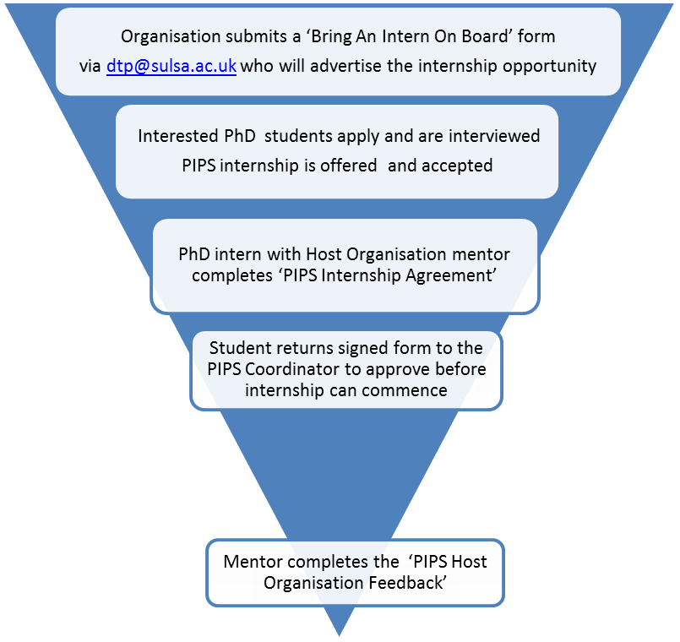

**PIPS begins**

**APPENDIX 2**

**Industry/Employment Sector List**

|  |  |
| --- | --- |
| Academia | Fire, Police & Security |
| Advertising, Marketing & Public Relations | Food & Beverage |
| Aerospace & Defence | Government & Civil Service (including public service administration) |
| Agriculture, Livestock breeding & Fishing (including production, animal welfare) | Health & Social Care |
| Biotechnology, Medical & Pharmaceuticals | Hospitality, Leisure, Travel, Tourism and Sports |
| Business and Management (including business intelligence & market research) | IT & Telecommunications (Hardware & Software) |
| Chemicals | Law (including legal services) |
| Clothing, Footware & Fashion | Logistics, Transport, Purchasing & Supply |
| Consultancy | Media, Communication, Journalism & Publishing |
| Charities & Voluntary work (non-profit / third sector) | Metals & Construction Materials |
| Creative arts, Design and Culture | Product Manufacturing |
| Education & Training (including teaching) | Real Estate & Renting |
| Energy & Utilities (including renewable energy and energy conservation) | Recruitment & Human Resources |
| Engineering (civil and mechanical) | Retail, Buying & Merchandising |
| Environment (including recycling, environmental services and industries) | Science & Research |
| Financial services (including accounting, auditing & banking) | Other |