PIPS Student Planning Sheet

*Please return this filled in form to the PIPS Coordinator (*[*dtp@sulsa.ac.uk*](mailto:dtp@sulsa.ac.uk)*) by 30th September of year 1 at the latest.*

|  |  |
| --- | --- |
| **Student details** | |
| Name |  |
| Email |  |
| Host University |  |
| Date started PhD |  |
| Title of PhD |  |
| PhD Abstract |  |
| **PhD Supervisor details** | |
| PhD Supervisor 1 Name |  |
| Email |  |
| PhD Supervisor 2 Name |  |
| Email |  |

|  |  |
| --- | --- |
| **PIPS Host Organisation details**  Ideally PIPS takes place in a **non-academic** setting.  It must provide you with work experience in a professional setting that does not relate directly to your PhD work. | |
| **Host Organisation Sector Type**  (please select from list in Appendix 1) |  |
| **What type of internship activity are you seeking?**  (Max 200 words please) |  |
| **Please detail your motivations for seeking this type of internship?**  (Max 200 words please) |  |
| **Details of potential Host Organisations identified in which PIPS may be carried out** | |
| 1. **Host Organisation Name** |  |
| Website |  |
| Does this organisation currently offer an internship program? |  |
| Name and Address of contact in organisation (if known) |  |
| Contact Persons Email and phone (if known) |  |
| Will this organisation provide physical premises external to the University with professional staff who will support the development of your professional skills appropriate to PhD level? |  |
| Is this internship an outreach or other project based within the University with professional staff who will support the development of your professional skills appropriate to PhD level?  Please note that University service providers and organisations that run virtually are not suitable for PIPS but there are rare circumstances where an internship based within the University environment is considered appropriate. Science outreach projects are one such example. | Please write a brief description of what the proposed project will involve and outline the range of professionals you will work with during this internship that are external to the University. |
| 1. **Host Organisation Name** |  |
| Website |  |
| Does this organisation currently offer an internship program? |  |
| Name and Address of contact in organisation (if known) |  |
| Contact Persons Email and phone (if known) |  |
| Will this organisation provide physical premises external to the University with professional staff who will support the development of your professional skills appropriate to PhD level? |  |
| 1. **Host Organisation Name** |  |
| Website |  |
| Does this organisation currently offer an internship program? |  |
| Name and Address of contact in organisation (if known) |  |
| Contact Persons Email and phone (if known) |  |
| Will this organisation provide physical premises external to the University with professional staff who will support the development of your professional skills appropriate to PhD level? |  |
| **Justification if choosing a PIPS provider(s) located greater than 50 miles from Host University** |  |
| **Please indicate if you will require any reasonable help from the PIPS coordinator?** |  |

|  |  |
| --- | --- |
| **PIPS Timing details** | |
| Planned PIPS start date |  |
| Planned PIPS end date |  |
| Planned PIPS format  Describe how it will fit into your research schedule (continuous placement or carried out in tranches) |  |

|  |  |
| --- | --- |
| **List details of the workshops or seminars you have completed or will complete in preparation for PIPS**  Please explore courses offered by local University Careers Service, Researcher Development, SULSA as well as free online course providers such as Coursera, EdX etc. (Project management training, Communication skills training, Entrepreneurship training, CV workshop, etc.) | |
| Name and date |  |
| Name and date |  |
| Name and date |  |

|  |  |
| --- | --- |
| **Will you be making an application to EASTBIO DTP for PIPS additional expenses?**  If so please supply the following: (please see PIPS Additional Expenses Application for Guidance) | |
| EASTBIO DTP additional expenses requested for travel |  |
| EASTBIO DTP additional expenses requested for accommodation |  |
| Total budget required |  |

|  |  |
| --- | --- |
| **Signed by:** | |
| PhD student |  |
| PhD Supervisor 1 or 2 |  |
| Date |  |

|  |  |
| --- | --- |
| **Approval:**  *Section to be filled in by management group representative or PIPS Coordinator.* | |
| Name of management group representative |  |
| Date |  |
| Signed |  |
| Recommendations for PIPS Approval  (if there are any)  Please note that approval at the 'PIPS Student Planning Sheet' stage is subject to the BBSRC criteria listed in the ‘PIPS Student Guide’ being met in the follow up 'PIPS Internship Agreement'. |  |
| Monitoring frequency  (concerns if there are any) |  |
| Eligible for EASTBIO PIPS Expenses application |  |

**APPENDIX 1**

|  |  |
| --- | --- |
| Academia | Fire, Police & Security |
| Advertising, Marketing & Public Relations | Food & Beverage |
| Aerospace & Defence | Government & Civil Service (including public service administration) |
| Agriculture, Livestock breeding & Fishing (including production, animal welfare) | Health & Social Care |
| Biotechnology, Medical & Pharmaceuticals | Hospitality, Leisure, Travel, Tourism and Sports |
| Business and Management (including business intelligence & market research) | IT & Telecommunications (Hardware & Software) |
| Chemicals | Law (including legal services) |
| Clothing, Footware & Fashion | Logistics, Transport, Purchasing & Supply |
| Consultancy | Media, Communication, Journalism & Publishing |
| Charities & Voluntary work (non-profit / third sector) | Metals & Construction Materials |
| Creative arts, Design and Culture | Product Manufacturing |
| Education & Training (including teaching) | Real Estate & Renting |
| Energy & Utilities (including renewable energy and energy conservation) | Recruitment & Human Resources |
| Engineering (civil and mechanical) | Retail, Buying & Merchandising |
| Environment (including recycling, environmental services and industries) | Science & Research |
| Financial services (including accounting, auditing & banking) | Other |

**APPENDIX 2**

**Responsibilities of PhD student for PIPS Process**

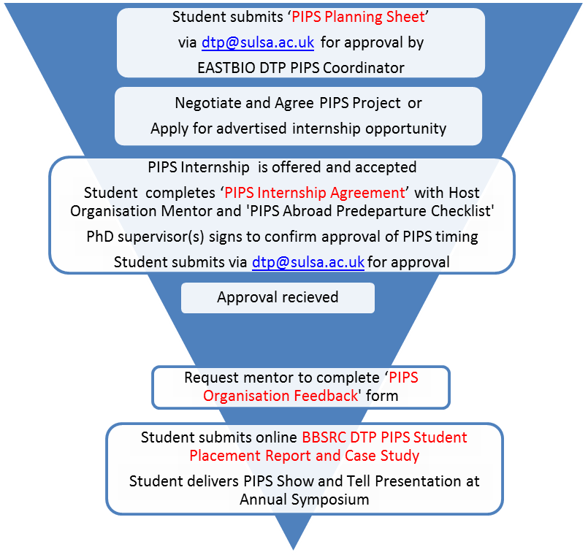

**PIPS Begins**

Deadline by end of first year 30 September

3 months after PIPS end date

Before month 39 of PhD

**EASTBIO Form 1**

**EASTBIO Form 2A**

**Form 2B only for overseas PIPS**

**EASTBIO Form 3 and Case Study**

**BBSRC Mandatory Report**