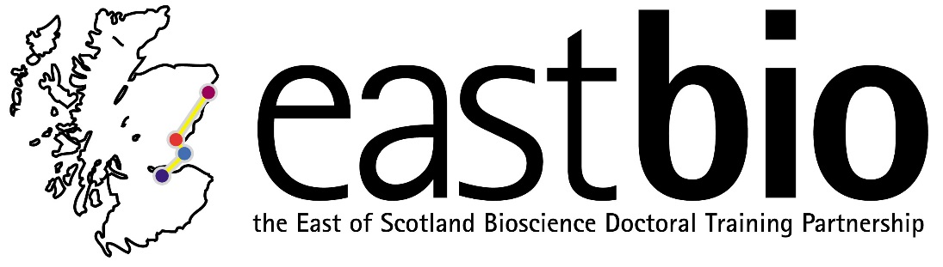
EASTBIO DTP Foundation Masterclasses 2017-2018
Training Strand 2: Bioscience Skills
Imaging Workshop
Workshop Leaders: Drs Dr Paul Appleton, Graeme Ball, Marcus Bischoff
Date: 26 January 2018, 9:00-17:00
Venue: Dundee, Venue TBC

Schedule:

09:00 onwards | Welcome and coffee/tea
09:00-11:00 | Imaging | Dr Marcus Bischoff (St Andrews)
11:00-12:00 | Super-Resolution Imaging | Dr Paul Appleton (Dundee Imaging Facility)
12:00-13:00 | Lunch, with coffee/tea
13:00-15:00 | Image Analysis | Dr Graeme Ball (Dundee)
15:15-17:00 | OMERO | OME Team (Dundee)

Learning outcomes:
By the end of the workshop the participants will have gained a good understanding of the principles of light microscopy and working with image data, as well as an overview of state-of-the-art techniques.

Summary:
The workshop will start with an introductory lecture giving an overview of different light microscopy techniques. We will cover the basics of transmitted light and epifluorescence microscopy and introduce various techniques, such as confocal, 2-photon and light sheet microscopy. Furthermore, live imaging techniques will be discussed. Next we take a look at the various super-resolution light microscopy techniques that have appeared in recent years (SIM, STED, PALM and STORM), reviewing the advantages and disadvantages of each. There will be a particular focus on Structured Illumination Microscopy (SIM), as found in Dundee's OMX system.

In the afternoon an introduction to image analysis and Fiji/ImageJ will be given. The participants will learn about different image types, handling and processing image data, segmenting images to define features of interest, making measurements, calculating statistics and preparing figures. This will be followed by an introduction to the OMERO image data management system: using the OMERO.insight client to import and view images, accessing images through OMERO.web, creating figures for publications using OMERO.figure, and using ImageJ/Fiji, Matlab and scripts with OMERO.

Requirements: All participants are requested to bring a laptop computer.

For any queries, email enquiries@eastscotbiodtp.ac.uk

