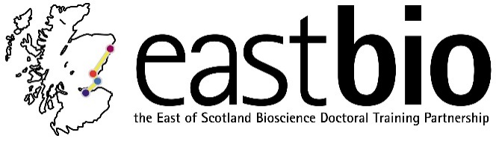
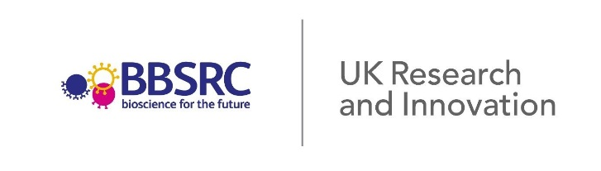
Thematic Research Training 2018-2019
Industrial Biotechnology and Bioenergy (IBB) group

Synthetic Biology for Industrial Biotechnology and Bioenergy
IBB Second thematic Meeting - 28th February 2019
University of Edinburgh, King’s Buildings

10.30-11.00 | Coffee/Tea | Waddington Building 1.08
11.00-12.00 | Talk from Dr Louise Horsfall  'Biologically Upcycling Metals’ | Waddington Building 1.08
12.00-13.00 | Lunch | Waddington Building 1.08
13:00-14:00 | Overview of the Edinburgh Genome Foundry | Waddington Building 1.08
 | Tour of the Edinburgh Genome Foundry | Michael Swann Building
14:00-14:00 | Coffee | Waddington Building 1.08
14.30-15.30 | Talk from Dr Katherine Dunn  Title: TBC | Waddington Building 1.08

Directions to Kings Building Campus from Edinburgh Waverly:
The easiest way to travel between the train station and the King’s Building Campus is by bus.
Buses 41, 42 and 67 all stop near the King’s Buildings, their respective bus stops near Edinburgh Waverly and the King’s Buildings are shown on the maps below:
Edinburgh Waverly Map:
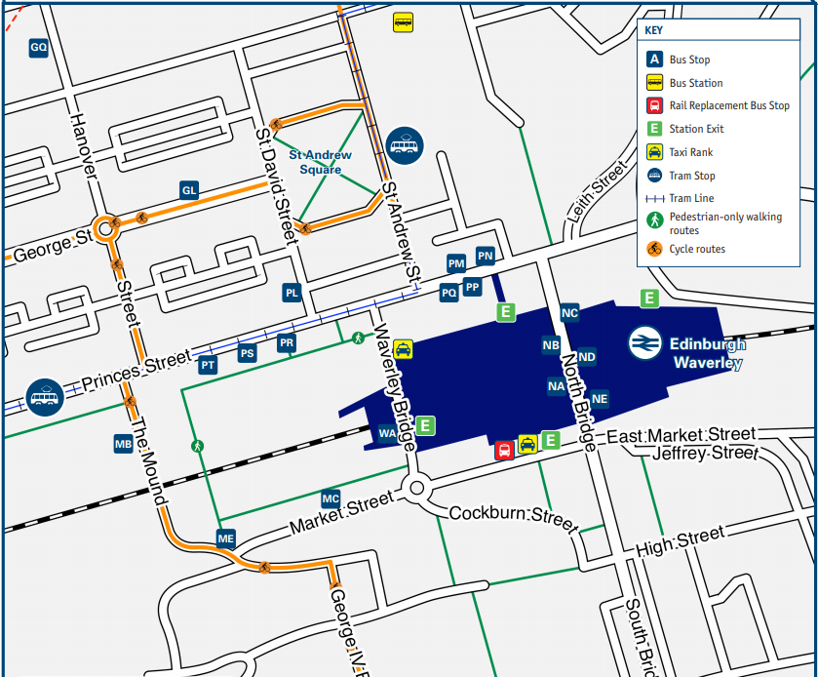
From stop ME labelled with a blue arrow on the Map the bus 41, 42 and 67 can be caught to the King’s Buildings
For any queries, please email student organiser Maggie Hicks at M.A.Hicks@sms.ed.ac.uk or EASTBIO at enquiries@eastscotbiodtp.ac.uk.

