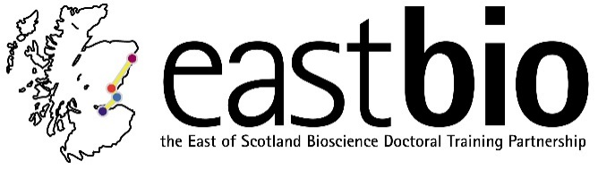
Thematic Research Training 2018-2019
Industrial Biotechnology & Bioenergy (IBB) group
Chair: Dr Rafael Guimaraes da Silva

Session 1: “Enzymatic catalysis” | Session 2: “Synthetic Biology for IBB” | Session 3: “Industrial Biotechnology and its applications” | Session 4: “Mental health during PhDs”  Jointly with the WCUB group
Session leaders (local organisers)  Host Supervisor:  Dr John Mitchell  mb105@st-andrews.ac.uk  Student organiser:  Eugene Shrimpton-Phoenix  esp1@st-andrews.ac.uk | Session leaders (local organisers)  Host Supervisor:  Dr Baojun Wang  baojun.wang@ed.ac.uk  Student organiser:  Margaret Hicks  m.a.hicks@sms.ed.ac.uk | Session leaders (local organisers)  Host Supervisor:  Professor Rebecca Goss  rjmg@st-andrews.ac.uk  Student organiser:  Hannah Lawther  hl87@st-andrews.ac.uk | Session leaders (local organisers)  Host Supervisor:  Nicola Stanley-Wall, Ulrich Zachariae, Sally Lowell  u.zachariae@dundee.ac.ukn.r.stanleywall@dundee.ac.uk  sally.lowell@ed.ac.uk  Student organiser:  Ryan Casement, Margarita Kalamara and Neil Thomson  r.casement@dundee.ac.uk; m.kalamara@dundee.ac.uk; njthomson@dundee.ac.uk
Programme available.  Date: 4 December 2018  Location: St Andrews | Programme available.  Date: 28 February 2019, 10:30-15:30  Location: Edinburgh, King’s Buildings | Programme available.  Date: 26 April 2019, 11:30-16:00  Location: St Andrews, Purdie Building | Programme TBC.  Date: 5 July 2019  Location: Dundee

