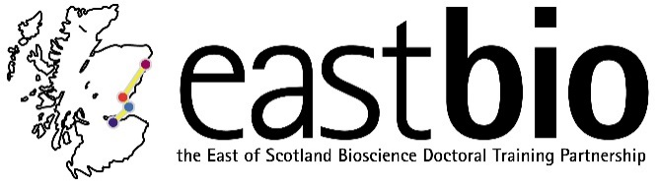
Thematic Research Training 2018-2019
Industrial Biotechnology & Bioenergy (IBB) group
Chair: Dr Rafael Guimaraes da Silva

Session 1: “Enzymatic catalysis” | Session 2: “TITLE” | Session 3: “TITLE” | Session 4: “TITLE”
Session leaders (local organisers)  Host Supervisor:  Dr John Mitchell  mb105@st-andrews.ac.uk  Student organiser:  Eugene Shrimpton-Phoenix  esp1@st-andrews.ac.uk | Session leaders (local organisers)  Host Supervisor:  Dr Baojun Wang  baojun.wang@ed.ac.uk  Student organiser:  Margaret Hicks  m.a.hicks@sms.ed.ac.uk | Session leaders (local organisers)  Host Supervisor:  Professor Rebecca Goss  rjmg@st-andrews.ac.uk  Student organiser:  Hannah Lawther  hl87@st-andrews.ac.uk | Session leaders (local organisers)  Host Supervisor:  Professor Nicola Stanley-Wall  n.r.stanleywall@dundee.ac.uk  Student organiser:  Margarita Kalamara  m.kalamara@dundee.ac.uk
Programme available.  Date: 4 December 2018  Location: St Andrews | Programme TBC.  Date: February 2019  Location: Edinburgh | Programme TBC.  Date: April 2019  Location: St Andrews | Programme TBC.  Date: June 2019  Location: Dundee

