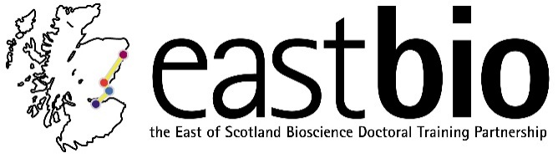
EASTBIO Research Skills Training (2017-2018)
Industrial Biotechnology & Bioenergy (IBB) group

Session 1: “Microscopy” | Session 2: “IBB meeting in tandem with the IBioIC's 4th Annual Conference” | Session 3: “Computation chemistry” | Session 4: “TBC”
Session leaders:  Ildiko Somerjai  imls@st-andrews.ac.uk  Student organisers:  Sarah Blincko  sb336@st-andrews.ac.uk | Session leaders:  Dom Campopiano  dominic.campopiano@ed.ac.uk  and Louise Horsfall  louise.horsfall@ed.ac.uk  Student organisers:  Ben Ashley  B.Ashley@warwick.ac.uk  Zak Towel  Zak.Towle@ed.ac.uk | Session leader:  Rafael de Silva  rgds@st-andrews.ac.uk  Student organiser:  Gemma Fisher  gf33@st-andrews.ac.uk | Session leader:  Attila Molnar  Attila.Molnar@ed.ac.uk  Student organisers:  Aron Ferenczi  s1238047@ed.ac.uk
Programme available.  Date: 22 November 2017, 9:45-16:00  Location: Beatson Institute, Glasgow | Programme of conference available. There will be a lunch-time EASTBIO-specific session, on ‘How to make the most of conferences,’ with Dr Deborah Fowlis (University of Edinburgh Careers) (Café at Technology and Innovation Centre)  Date: 25(-26) January 2018  Location: IBIOIC annual conference, Glasgow | Programme available.  Date: 25 April 2018  Location: St Andrews | Programme TBC.  Date: June 2018  Location: Edinburgh

