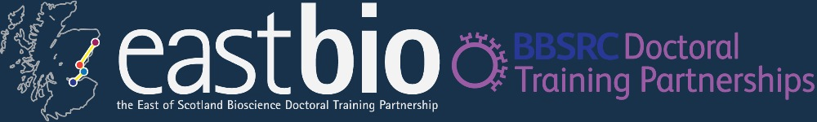

Session 1. Public Engagement Meeting
Bioenergy and Industrial Biotechnology Research Theme
10:30-16:00 25th November 2014
University of Dundee
Life Sciences CTIR building
Room MR 284

Time | Presentation
10:30-10:40 | Introduction – Dr. Alex Brand
10:40-11:40 | Scientific Presentations  Give a 5 minute presentation on the topic of your research aimed at your peers with 5 minutes for questions.
11:40-12:30 | Outreach Speaker – Professor Carol MacKintosh  Carol will present the BBSRC 'Excellence with Impact' visions of the University of Dundee, which reflect a spirit of transformation in this city, rooted in scientific excellence and cultural verve. She will also present an Impact Case Study entitled 'A distillation of cell signaling research and water toxicology'.
12:30-13:30 | Lunch
13:30-14:00 | Public Engagement Speaker  A talk on how to present scientific research to the public and the key information needed.
14:00-15:00 | Explain Your Work to the Public – Presentation Workshop  Write a 5 minute talk aimed at a group of interested non-scientist adults (or age-group of your choice) explaining your work and why it is important. Students will work with (or using advice from) Prof. MacKintosh and the other group leaders.
15:00-16:00 | Explain Your Work to the Public – Presentation and Discussion  Give a 5 minute presentation aimed at a group of interested non-scientists with 5 minutes for discussion.

