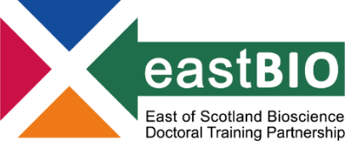
Thematic Research Training 2022/23
Integrated Understanding of Health group
Chair: Dr Tom Otto (University of St Andrews)

Session 1:  “Models for bioscience” |  | Session 2:  “Advanced methods in bioscience” |  | Session 3:  “Data-driven and computational approaches” |  | Session 4:  “Scientific Communication / Impact”
Session 1 leaders  Broc Drury |  | Session 2 leaders  Gabriele Bagusinskaite |  | Session 3 leaders  Rosie Gallagher |  | Session 4 leaders  Erin Watson
Host supervisors:  James Minchin,  Calum Bain,  Tim Czopka | Host students:  Broc Drury,  Haya Al Siyabi,  Emma Dumble | Host supervisors:  Sander Granneman | Host students:  Gabriele Bagusinskaite, Robyn Greene | Host supervisors:  Silvia Paracchini,  William Farnaby, Kim Dale | Host students:  Mariya Shtumpf,  Andreas Holmqvist,  Rosie Gallagher | Host supervisors:  Kathy Evans,  David O'Hagan,  Elaine Emmerson | Host students:  Eleanor Stamp,  Josephine Stewart,  Erin Watson
16 December 2022  Edinburgh |  | 24 March 2023  Edinburgh, Informatics Forum |  | 24 April 2023  Dundee |  | 14 June 2023  Edinburgh

Check the training page http://www.eastscotbiodtp.ac.uk/thematic-training frequently for meeting updates.

