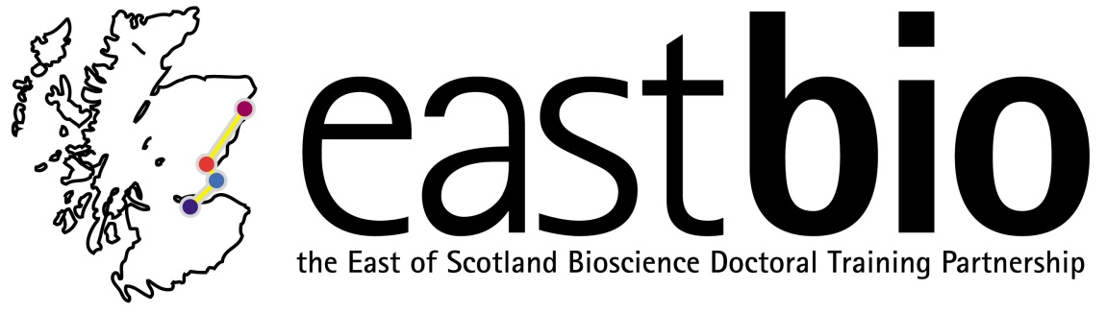

EASTBIO Training Strand 1: Research Skills - 2014/15
Food Security priority area

Organised by the University of Aberdeen

2 April 2014, University of Aberdeen

Introduction to the programme, Blackboard Collaborate refresher and plans for the coming year.

List of discussion topics

July 2014

Professor Adam Price – “Plant biotechnology for Food Security”. The session scheduled for Tuesday 8 July, 10:00-11:00 with a general introduction on GM crops.

Please note: A recording of this session is available on the EASTBIO website (http://www.eastscotbiodtp.ac.uk/student-resources), restricted to accredited users. Contact enquiries@eastscotbiodtp.ac.uk for access information.

August 2014

Dr Paul G. Fernandes – “Food security issues for commercial fisheries”. The session will be held online at the following dates/times:

Session 1 | 8 August | Introduction and setting of main task: respond to the question: What is the status of European fish stocks? Students to consider the evidence as presented in three types of sources:  - evidence from the scientific literature;  - evidence from text books;  - evidence from websites and the popular press
Session 2 | 15 August | Students to report back, tutorial and discussion on seafood security
Session 3 | 22 August | Final session with reflection on the topic

September 2014

Jon J. Hillier/ Pete Smith – “Intensification or extensification” OR “What is the carbon cost of achieving secure food production in developing countries?”. Discussion-based session held on Monday 29 September, 10:00-12:00.

October 2014

Jayne Hope – “Contribution of large animal scientific research to long term food security”

November 2014

Prof David E. Salt – ‘Can genomics help farmers secure crop production in the face of a changing global climate?’. The session will be held online at the following dates/times:

Session 1 | 3rd November at 2-3pm | Provide introduction and set out work to be done
Session 2 | 14th November at 2-3pm | Students discuss what they found out and refine new work to be done
Session 3 | 24th November at 2-3pm | Finalise discussion and round off

December 2014

Karen Halliday – “Food security in a changing climate”

March-April 2015

Baukje de Roos/ Janet Kyle – “Foods, security and human health”

Session 1 | 12th March, 2-3pm | Provide introduction and set out work to be done
Session 2 | 19th March, 2-3pm | Students discuss fish and meat questions: what they found out & refine new work to be done
Session 3 | 2nd April, 2-3pm | Students discuss impact population growth on provision of a sustainable healthy balanced diet
Session 4 | 9th April, 2-3pm | Final discussion and round off

Three questions to be raised:

- Current recommendations highlight a healthy diet should include at least two portions of fish a week, one oily and one white fish. Is this recommendation achievable and sustainable? Consider the role of aquiculture.

- The negative health and environmental impacts of meat production and consumption have been widely debated in recent years, with the common message highlighting a need to reduce meat intake. Is a plant-based diet achievable? Is there sufficient land and water to sustainably produce the qualities of food required?

- Healthy balanced diets include land and aquatic-based food items. Can we meet a growing global populations’ dietary and nutrient needs?

April 2015

Chris Secombes – “What are the issues facing sustainable production of fish by aquaculture”

