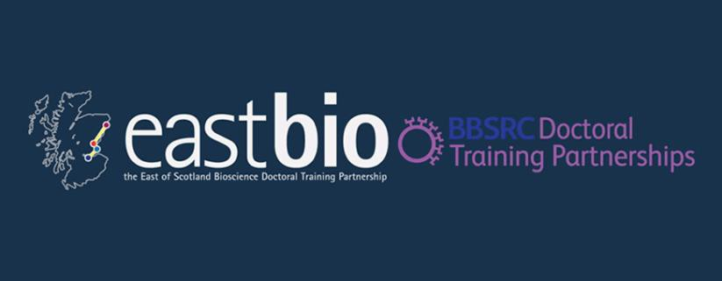

EASTBIO Research Training Strand 1: Food Security Priority Area

Session 3: “Climate change and sustainability (crops – agriculture)”

Friday 5th June 2015, 10:30-6:00

Old Seminar Room, James Hutton Institute, Dundee

Hosts: Estela Torres (EASTBIO) & Max Coulter, Rodrigo Alegria Terrazas (SFSA-Crops students)

Programme:

10:15am: Arrival, Tea/Coffee and Introductions
* Please go in the main entrance of JHI and we will meet you and take you to the Pld Seminar Room

10:45am – 12:45pm: Climate change and sustainability (crops – agriculture)

Presentations: Scene-setting - Overview of climate change and sustainability; impact on plants and soils: Terry Dawson (UoD); Tim Daniell (JHI); Davide Cammarano (JHI)

Short presentations from Estela, Max, Rodrigo and Heine to pose key questions for discussion.

Discussion

12:45pm – 1:30pm: Lunch

1:30pm – 2.30 pm: GMOs and the EU
(Howard Davies, JHI, European Food Safety Authority)

Discussion

2.30pm – 3:00pm: Tour of transgenic facility (Jennifer Stephens, JHI)

3:00pm – 3:30pm: Wrap up and depart

