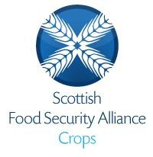
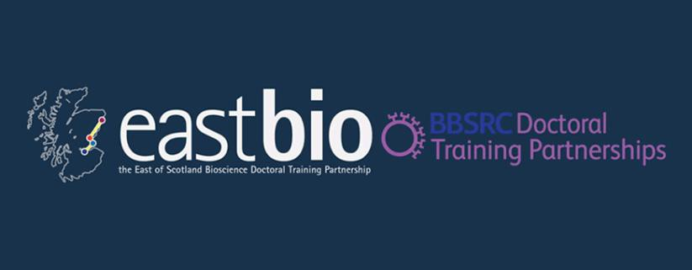

EASTBIO Research Training Strand 1: Food Security Priority Area

Session 4: “Genetic modification in food security“

Friday 18th September 2015, 11:00-16:00

G.020, The Roslin Institute, University of Edinburgh

Hosts: Adam Clement and James Prendergast

Programme:

11:00 – Arrival, Tea/Coffee
* Just go through the main entrance and you should find us to the right, just past the reception desk. We’ll go to the meeting room shortly after.

11:30 – 12:30: Tour of Roslin’s XTEN sequencing facility Javier Santoyo-Lopez (Bioinformatics Operations Manager)
*We’ll go in two groups, approx. 15 mins each.

12:30 – 13:30: Magic cow – A transgenic approach to induce African Trypanosomiasis resistance in cattle. Professor Bruce Whitelaw (Animal Biotechnology)

13:30 – 14:00: Lunch

1400 - 15:00: Engaging the public with your research – Dr Nicola Stock (Roslin's Public Engagement Officer).
* This session is interactive and will help develop your abilities to engage the public in your science. As in email, please prepare 140 character length (tweet-esque) description of your work. Imagine you're writing it for someone who isn’t an expert in science but is interested in learning about your research.

15:00 – 15:45: Empowering science in food security.
*Presentation on communicating ‘controversial science’ in food security in order to empower scientists and the public in the pursuit of food security solutions, followed by discussion.

15:45 – 16:00: Wrap-up

