Would you like to gain research experience this summer?
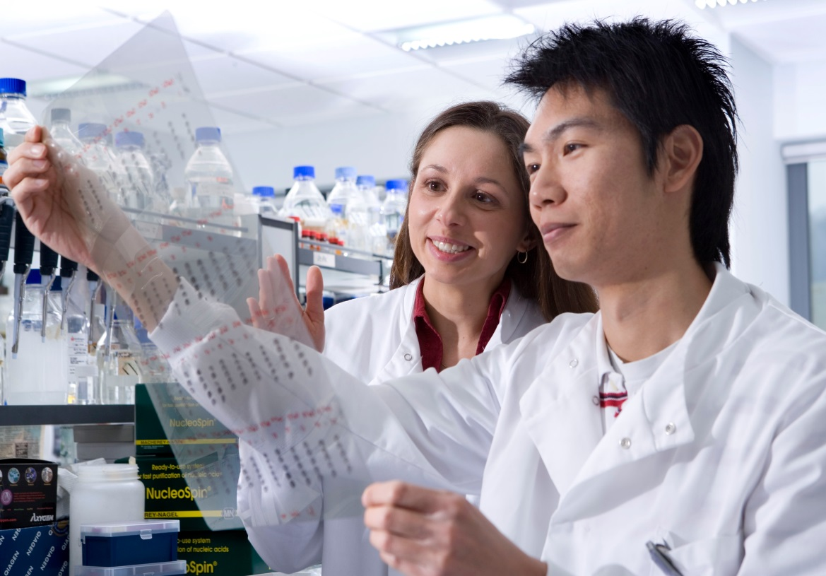
BBSRC-funded undergraduate
Research Experience Placements
Bioscience for Health Food Security
World-class Bioscience Biotechnology and Bioenergy

For application form and further information please visit:
www.eastscotbiodtp.ac.uk
Application deadline: 30 March 2018

