EASTBIO Induction 2022 – 3rd October 2022
Stirling House Hotel, Stirling

Contents
Welcome 2
Schedule 3
Induction activities and sessions 5
Thematic Training Break-Out Sessions 5
2022/23 Student Handbook 5
Accommodation 6
Dinner 6
Transport 6
By Car 6
By Coach 7
By Train 7
Feedback 7
Consent and privacy notice 7
Contact details 7

Welcome
Thank you to all those who registered for the EASTBIO Induction Day 2022. This event is an introduction to the EASTBIO Training Programme 2022/23 and therefore not to be missed by new students and their supervisors, particularly those who are new to EASTBIO; we have asked supervisors unable to attend to name a lab member who can attend in their place, wherever possible.
As we have planned all sessions to be interactive and have kept the talks to a minimum, we are sorry that we cannot provide a remote joining option. If you are unable to attend, what we can offer is one-on-one meetings with the DTP Manager and/or Support Officer to go over our training requirements with you and your supervisor, as necessary; please email us and we will organise an online meeting for you.

Students attend EASTBIO Symposium 2022
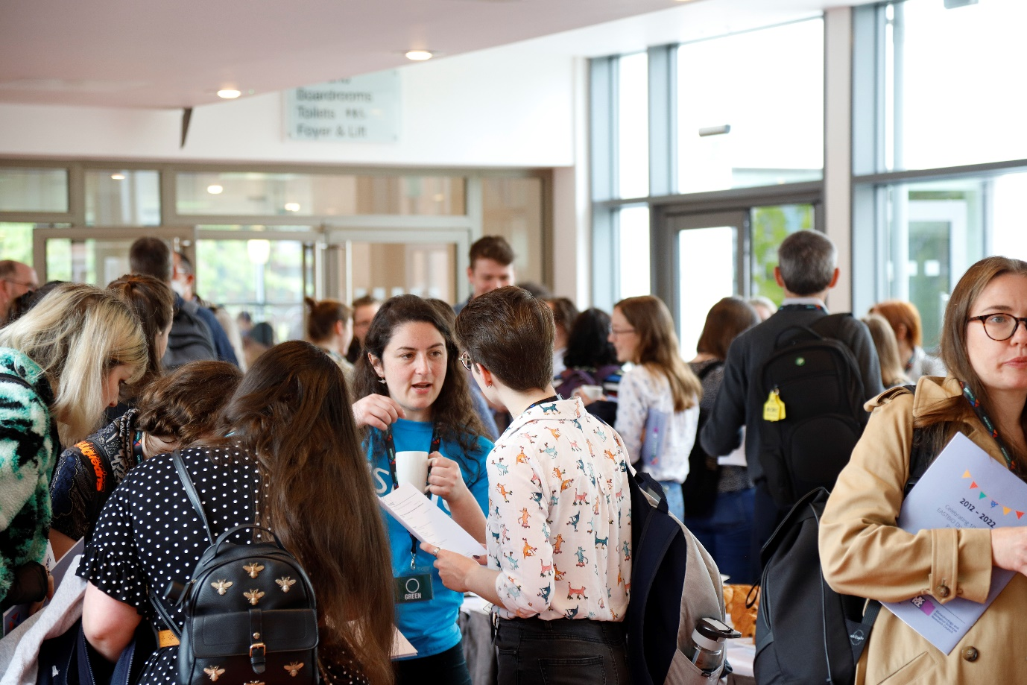

Schedule
EASTBIO Induction & Training Day 2022 | #eastbioInduction22
3 October, 10:00-17:00 & 4 October, 9:00-13:00
Stirling Court Hotel, Stirling

Induction Day 1 – 3 October 2022, 10:40-17:00
10:00-10:40 | Registration and coffee
10:40-11:10 | Welcome and Introduction to the Training Programme, Placements & EDI Support  Dr Sam Miller (EASTBIO Deputy Director, University of Aberdeen)  Dr Selma Cabrita Gulyurtlu (University of Dundee) |  |  | Blair Atholl
 | Parallel Sessions
11:10-11:40 | Getting to know you  Chairs: Megan Davies and Lauren Ferguson (Stirling Careers Service)  This short session will give you the chance to speak to other students. Be ready to chat, find out a bit more about each other and share fun facts about yourself!  We suggest being active in the research community on Twitter; for reasons why, read this article. As part of this session, we’ll be creating a Twitter community #phdchat.  Blair Atholl | EASTBIO supervisors’ session  Chairs: EASTBIO Management Group  Hermitage Iona
11:40-12:00 | SysMIC course – An Introduction  Chair: Dr Gerold Baier  (SysMIC/University College London)  Blair Atholl | EASTBIO Supervisors break-out preparation  Chairs: EMG members and DTP Manager  Hermitage Iona
12:00-13:30 | Group photo and Lunch  Students to check in their rooms |  | Restaurant
13:30-15:10 | Thematic groups break-out sessions  All groups to break in separate group discussion, then re-convene in Blair Atholl for 15:00 when coffee will be served.  - Clean Growth group – Dollar  Chair: Dr Gerben van Ooijen  - Crops and Soil group – Callandar  Chair: Dr Craig Simpson  - Integrated Understanding of Health – Hermitage Iona  Chair: Dr Tom Otto  - Livestock and Aquaculture group – Erskine  Chair: Professor James E. Bron  - Understanding the Rules of Life group – Blair Atholl  Chair: Dr Sam Miller
 | Parallel Sessions
15:10-16:00 | Q&A session (students only)  Chairs: EASTBIO student reps  Blair Atholl | Q&A session (supervisors only)  Chairs: EASTBIO Management Group  Hermitage Iona
16:00-16:30 | 2022 cohort to reconvene at the end of the Q&A session for a final wrap up  Close of Induction
17:00 | Transport to Edinburgh for delegates who have registered for transport.
18:30 | Dinner at the Hotel
Induction Day 2 - 4 October 2022, 9:00-13:00
Students only
Training Day: Statistics and Experimental Design masterclass Part B
Dr Graham Horgan
Biomathematics & Statistics Scotland - BioSS; Rowett Institute, University of Aberdeen
9:00-10:45 | Statistics and Experimental Design masterclass (including Q&A)  Hermitage Iona
10:45-11:15 | Tea/Coffee break
11:15-13:00 | Statistics and Experimental Design masterclass (including Q&A)  Hermitage Iona
13:00 | Lunch  Close of EASTBIO Training Day

Induction activities and sessions
Induction Day marks the launch of the EASTBIO 2022/23 Training Programme. This is when you find out about our programme, our provision, and our expectations. This covers year-by-year training courses and events organised by EASTBIO: including training and practice opportunities on foundational and advanced research skills, professional skills, enterprise skills, and transferable skills, as well as public engagement and cohort-building opportunities.
We will introduce the PIPS scheme including our expectations and support for your personal and professional development and our mechanisms to engage you and your supervisors. We will make sure that everyone has plenty of opportunity to discuss, ask questions and make the best of meeting our team and supervisors for the first time.
On the 3 October, at 11:10, we will run an activity for students only, “Getting to Know You”, delivered by the University of Stirling Careers Service team, with the aim of making quick introductions and sharing of information about you and your research. Be prepared to connect!
If you are a student attending induction, then please bring your laptop, if possible, as you will need this for the training day on 4th October 2022.

Thematic Training Break-Out Sessions
The Thematic Training break–out sessions have pride of place on the schedule. You and your supervisors will shortly receive a separate email about what is expected from you regarding these sessions.
In the break-out sessions, the 2022 cohort will split into five sub-cohorts based on your PhD project’s thematic area (BBSRC priority areas) and each group will discuss the four individual sessions that you will plan as a group during your first year, with support from your supervisors (academic guidance) and the EASTBIO team (logistical assistance). A follow-up email will provide more details and resources for that part of the Induction.

2022/23 Student Handbook
EASTBIO will circulate an updated copy (pdf) of the Student Handbook in advance of the Induction and we ask you to read it carefully before you arrive in Stirling. This is to ensure that you will come prepared to engage with the members of the EASTBIO Management Group and the team with your questions, comments, suggestions, and ideas on the programme we are running this year.
Each student and supervisor will receive a printed copy of the Revised Handbook at registration. We will inform all when we will have updated all the training webpages at http://www.eastscotbiodtp.ac.uk/year-1-foundation-training.

Accommodation
EASTBIO provides free overnight accommodation for students attending induction – single occupancy double rooms with breakfast – for the 3 October to all students who have registered for the Induction.
Check in is at 14:00 and check-out at 11:00. There will be a safe room at the Hotel for attendees’ luggage during the day.

Dinner
EASTBIO will provide all meals at the Stirling Court Hotel, including hot drinks, pastries and bacon rolls on arrival (3 October), and a buffet dinner for students with coffee/tea as follows:
Main course – selection out of the 3 options
- Classic beef bourguignon
- Lemon roasted salmon
- Parmesan roasted vegetables
Served with – 2 options
- Crispy baked potato
- Steamed rice
You can have one glass of house wine (red or white), with a soft drink/water alternative; alcohol to be consumed before you take your seat in the dining area out of respect for some of our guests’ beliefs.
All dietary requirements recorded on the online registration form were passed on to the Hotel and will be accommodated; you can still email us before the event if you have failed to provide that information.

Transport

By Car
There is parking available at the Hotel car park. You will need to register your car registration number at reception on arrival. There are some carpool arrangements in place for students travelling from Aberdeen, Dundee, and St Andrews.
From the East, South or West take the M9 to Junction 11. At the junction, there is a roundabout which marks the end of the M9. From here you should take the exit for Bridge of Allan, follow the road through the town itself, and after about 200 metres you will find the University entrance on the left.
From the North take the A9 to the same roundabout and follow the same route through Bridge of Allan as above.

By Coach
Those travelling from Edinburgh can use the EASTBIO provided coach. This will leave from two sites The Roslin Institute at Easter Bush and the Swan Building at the Kings Building Campus.
The bus will depart at 8am sharp from the Roslin Institute at the Easter Bush Campus and 8.30am from outside the Swan Building at the Kings Buildings Campus and will not wait for latecomers. Campus maps can be downloaded at https://www.ed.ac.uk/maps/download.
The bus will depart from Stirling Court Hotel at 5pm of the 3 October for those leaving that afternoon and at 14:00 on the 4 October.

By Train
You can get a train to Stirling and then either choose to walk to the hotel (40 minutes) or use one of the two park and ride routes in Stirling, situated at Castleview and Springkerse, with buses every 12 minutes to and from Stirling city centre. From Stirling city centre, you can access First Bus routes UL and 54, both of which serve the Stirling campus

Feedback
You are kindly asked to tell us what you thought of the Induction & Training Days and offer us your suggestions about improving them in future. Please complete the short questionnaire on https://forms.gle/jiqxays3UEWf7Ghi8 by the 6 October 2022.

Consent and privacy notice
We ask you to fill in the attached Consent Form in view of our plan to have a professional photographer on the 3 October who will taking photographs of students and supervisors, including a scheduled group photo before lunch at 12:00.
The photos are to be used for our website (http://www.eastscotbiodtp.ac.uk/), the annually updated Student Handbook and other publicity materials, such as presentation slides, webpages, blogs, etc. by the EASTBIO team.
Please speak to a member of the EASTBIO team at registration if you have further concerns in this respect or email us about this before the Induction.

Contact details
For further queries, please email enquiries@eastscotbiodtp.ac.uk

