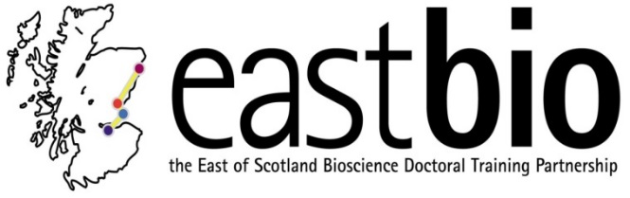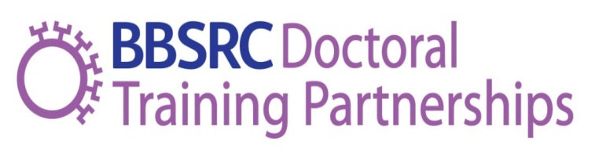
EASTBIO Induction Day
Wednesday 3 October 2017, 10:00-17:00
West Park Conference Centre, Dundee
10:00-10:30 | Registration and coffee |  | Balbeggie Room
10:30-10:40 | Group photo, followed by Welcome and introduction  Professor Clare Blackburn (EASTBIO Director, University of Edinburgh) |  | Balbeggie Room
10:40-11:10 | EASTBIO Training Programme  Professor Bernadette Connolly (EASTBIO Deputy Director, University of Aberdeen) |  | Balbeggie Room
11:10-11:40 | Professional Internships for PhD Students (PIPS)  Dr Caroline Pope (PIPS Coordinator, University of Edinburgh) |  | Balbeggie Room
11:40-12:00 | SysMIC course – An Introduction  Dr Gerold Baier (SysMIC lead/University College London) |  | Balbeggie Room
12:00-13:00 | Lunch |  | Henderson’s Restaurant
13:00-13:30 | Interdisciplinary skills in biosciences, with an Introduction to the break out and Q&A sessions  Dr Rafael Guimaraes da Silva (EASTBIO co-Director, University of St Andrews) |  | Balbeggie Room
13:30-15:00 | Theme groups break-out sessions  Chairs:  - AFS: Bernadette Connolly  - IBB: Rafael Guimaraes da Silva  - BfH: Edgar Huitema  - WCUB: Vicky Macrae  Coffee will be served outside the rooms at 14.30 |  | - Agriculture and Food Security (AFS)– Glen Esk  - Industrial Biotechnology & Bioenergy (IBB) - Glen Clova  - Bioscience for Health (BfH) - Glen Doll  - World Class Bioscience (WCUB) - Balbeggie Room
15:00-16:00 | Q&A session for EASTBIO students  Chaired by EASTBIO student reps and Maria Filippakopoulou  Balbeggie Room | Q&A session for EASTBIO supervisors  Chaired by EMG  Glen Esk
16:00-17:00 | Close of Induction with Drinks Reception & canapes |  | Abernyte
17:00 | Transport home for Edinburgh-based supervisors; students to check in the Invercarse Hotel
20:00 | Dinner at West Park; accommodation (Invercarse Hotel); return to West Park (Balbeggie Room) for the Masterclass on Thursday 4th October, 9:00-13:00 (soup & sandwiches lunch served at 13:00-14:00) |  | Longforgan Room (West Park)

