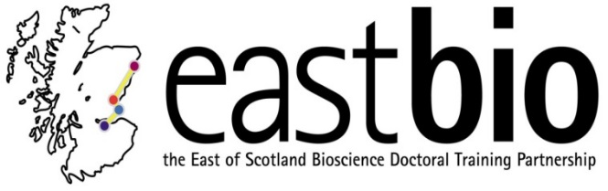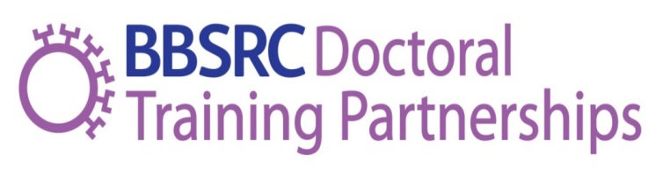
EASTBIO Induction Day
Thursday 5 October 2017, 10:00-17:00
West Park Conference Centre, Dundee
10:00-10:30 | Registration and coffee |  | Balbeggie Suite
10:30-10:40 | Welcome and introduction  Irina Stancheva (EASTBIO Academic Management Group Representative, University of Edinburgh) |  | Balbeggie Suite
10:40-11:10 | EASTBIO Training Programme  Professor Bernadette Connolly (EASTBIO Academic Management Group Representative, University of Aberdeen) |  | Balbeggie Suite
11:10-11:40 | Professional Internships for PhD Students (PIPS)  Dr Caroline Pope (Postgraduate Placement Coordinator, University of Edinburgh) |  | Balbeggie Suite
11:40-12:00 | SysMIC  Dr Gerold Baier (SysMIC & Department of Cell and Developmental Biology, University College London) |  | Balbeggie Suite
12:00-13:00 | Group photo followed by lunch
13:00-13:30 | Interdisciplinary skills in biosciences and an Introduction to the break out and Q&A sessions  Dr Judith Sleeman (EASTBIO Academic Management Group Representative, University of St Andrews) |  | Balbeggie Suite
13:30-15:00 | Theme groups break-out sessions  Chairs:  - FS: Bernadette Connolly  - IBB: Judith Sleeman  - BH: Carol MacKintosh (University of Dundee)  - WCUB: Vicky MacRae  Coffee will be served to each room at 14.30 |  | - Agriculture and Food Security (FS)– Balbeggie Suite  - Industrial Biotechnology & Bioenergy (IBB) - Glen Clova  - Bioscience for Health (BH) - Glen Doll  - World Class Bioscience (WCUB) - Glen Esk
15:00-16:00 | Q&A session for EASTBIO students  Chaired by Maria Filippakopoulou & current student reps  Balbeggie Suite | Q&A session for EASTBIO supervisors  Chaired by EMG  Glen Esk
16:00-17:00 | Drinks Reception |  | Longforgan Room
17:00 | Transport home for Edinburgh-based supervisors  Students go on to accommodation, dinner and Masterclass on Friday 6th October

