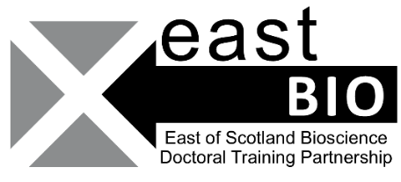
Thematic Research Training 2022-2023
Crops and Soil group
Session 2: Omics (Including genomics, pangenomics and proteomics)
University of Dundee, 21 February 2023, 9:45-17:00
Event description:
TBC
Session Schedule:
Times | Sessions
10:00-10:30 am | Welcome (Coffee)
10:30-11:15 am | Talk by Dr Micha Bayer- Pangenomics
11:00-11:30 am | Q&A
11:30 am-12:30 pm | Interactive workshop
12:30-13:30 pm | Lunch break
13:30-14:15 pm | Journal club
14:15-14:30 pm | Coffee break
14:30-3:30 pm | Workshop
3:45-4:30 pm | Final talk
4:30-5:00 pm | Closing statements

Session organisers: Cristina Ponce Lilly C.Ponce-Lilly@sms.ed.ac.uk; Alasdair Iredale (University of Dundee) and Emma Hardy (University of Dundee)
Email enquiries@eastscotbiodtp.ac.uk if you have any questions about the session.

