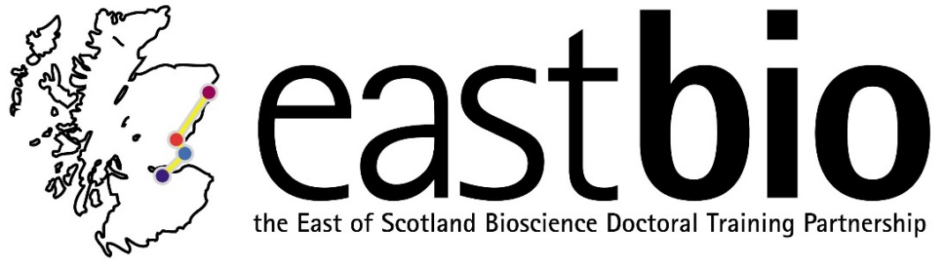

EASTBIO DTP Foundation Masterclasses 2018-2019
Genomic Approaches

Masterclass leader: Professor Mick Watson (The Roslin Institute, University of Edinburgh)

Date: 8 March 2019, 10:15-15:30

Venue: TBC, Dundee (map link)

Schedule:

10:15-10:30 | Arrival and coffee/tea
10:30-11:00 | Introduction, background and sequencing technologies
11:00-11:30 | Genome re-sequencing and variant-calling
11:30-12:15 | Lunch & coffee/tea
12:15-12:45 | RNA-Seq and other functional genomics
12:45-13:15 | Genome assembly and contaminant identification
13:15-13:45 | Metagenomics
13:45-14:15 | Coffee/tea
14:15-14:45 | Bioinformatics, open science, programming, Bio* projects
14:45-15:30 | Panel session Q&A & close

Summary:

The aim of this masterclass is to introduce the students to the concepts involved in genomics, including sequencing technologies and large-scale data analysis. The masterclass will be run by a group of young, enthusiastic and practicing researchers from Scotland who have huge experience in analysing large genomic datasets.

On completion of the course, the students will be able to:
- Discuss the pros and cons of current sequencing technologies
- Understand the concepts and methods behind:
  - Genome re-sequencing and variant calling
  - RNA-Seq and functional genomics
  - Genome assembly and contamination
  - Metagenomics and the microbiome
  - Bioinformatics software development and open source projects

Requirements: Enthusiasm

For further questions, please email enquiries@eastscotbiodtp.ac.uk.

