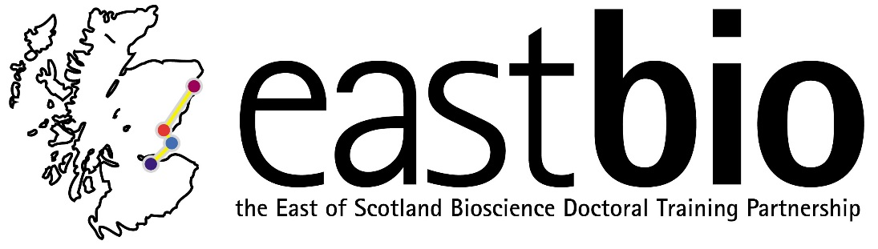
EASTBIO DTP Foundation Masterclasses 2017-2018
Training Strand 2: Bioscience Skills

Introduction to Matlab
Masterclass leader: Dr Søren K. Andersen (University of Aberdeen)
Date: 12 January 2018, 9:30-17:00
Venue: Dundee, venue TBC
Learning outcomes:
- Enable students with minimal prior coding experience to perform simple computations in Matlab;
- Convey an overview of the specific strengths and weaknesses of Matlab.
Proposed schedule:
9:30-10:00 Welcome and Coffee
10:00-12:00 Basics, Math & Variables (Presentation & Exercise 1)
12:00-13:00 Lunch
13:00-15:00 Logical Operators, Scripts, Functions and Flow Control (Presentation & Exercise 2)
15:00-15:30 Coffee
15:30-17:00 Statistics and Plotting (Presentation & Exercise 3)
17:00 Close of masterclass

Matlab (Matrix Laboratory) is a numerical computing platform and a programming language. Matlab’s powerful basic capabilities can be extended by a variety of commercial and open source toolboxes and it is widely used in many fields of science and engineering.
The present course provides an introduction to Matlab and requires minimal previous knowledge. Through a combination of presentations and hands-on exercises, participants will gain a knowledge of the Matlab syntax and learn how to perform simple calculations and plot data. Exercises will include optional challenges for participants who already have some programming skills.
Requirements: All participants are requested to bring a laptop computer with Matlab (or its freely available clone Octave) installed.

For further queries, email enquiries@eastscotbiodtp.ac.uk

