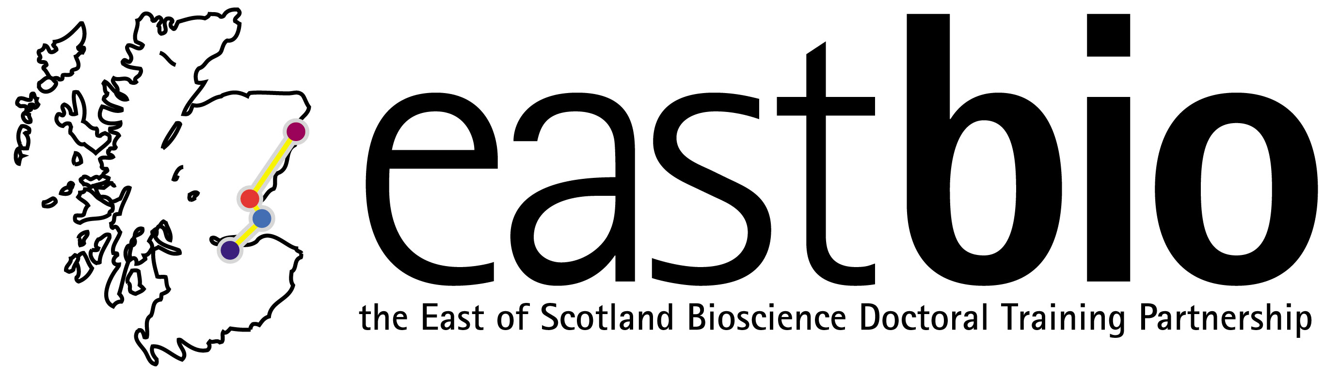

EASTBIO DTP Training Day

Statistics and Experimental Design masterclass

Masterclass Leader: Dr Margo Chase-Topping (Centre for Immunity, Infection and Evolution, University of Edinburgh)

Date: Thursday 4 October 2018, 9:00-13:00
Venue: Balbeggie Room, West Park Conference Centre, Dundee

Learning outcomes:
This masterclass is meant to give students an overview of the important concepts in research design. It is aimed at in-coming PhD students with limited statistical experience. Discussions will focus on the steps leading up to the statistical analysis of data. However, more advanced students can feel free to explore the data using the statistical package of their choice. In addition, if students have their own data they can use the opportunity to ask specific questions relating to their project.

Summary:
Statistics is the body of techniques used to facilitate the collection, organization, presentation, analysis and interpretation of data for the purpose of making better decisions. This definition encompasses such concepts as experimental design, database management as well as statistical analysis of data. The goal of this course is to provide students with an introduction to the tools that are necessary to conduct research. We will begin with the development of the research question and follow this with discussions about the design of a study including data collection, storage and exploratory data analysis.

Masterclass outline:

Time | Description
09:00-09:45 | Developing scientific questions (coffee available on arrival)
10:00-10:45 | Designing methodology
10:45-11:00 | Coffee break
11:00-13:00 | Analysing data:  - Database construction  - Choice of Statistical package  - Exploratory Data Analysis (EDA)
13:00-13:30 | Soup & sandwiches lunch & Close of Training Day

Requirements:
All participants are requested to bring a laptop computer * Please arrive with your laptops fully charged as there may be shortage in plugs in the room * Prior to the class all students will be given some spreadsheets (.csv) with data that we will discuss. These files will be viewed in Excel. Students with more experience with statistical analysis may wish to explore the data further using the statistical package of their choice (for example, Minitab, SPSS, R). These packages will need to be loaded onto laptops in advance of the course.

For any queries, email enquiries@eastscotbiodtp.ac.uk

