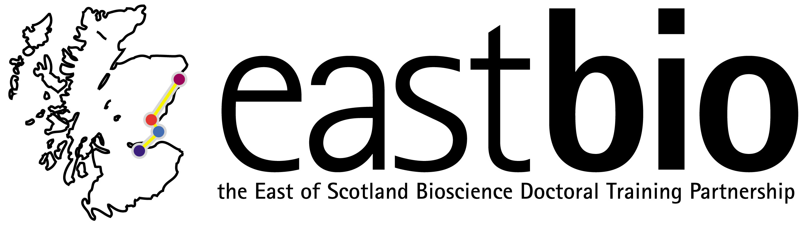

EASTBIO DTP Training Day

Statistics and Experimental Design masterclass

Masterclass Leader: Dr Margo Chase-Topping (Centre for Immunity, Infection and Evolution, University of Edinburgh)

Date: Friday 6 October 2017, 9:00-13:00
Venue: Balbeggie, West Park Conference Centre, Dundee

Statistics is the body of techniques used to facilitate the collection, organization, presentation, analysis and interpretation of data for the purpose of making better decisions. This definition encompasses such concepts as experimental design, database management as well as statistical analysis of data. The goal of this course is to provide students with an introduction to the tools that are necessary to conduct research. We will begin with the development of the research question and follow this with discussions about the design of a study including data collection, storage and statistical analysis.

Masterclass outline:

Time | Description
09:00-09:45 | Developing scientific questions
09:45-10:00 | Coffee & bacon croissants break
10:00-10:45 | Designing methodology
10:45-11:00 | Break
11:00-13:00 | Analysing data:  - Database construction  - Choice of Statistical package  - Exploratory Data Analysis (EDA)
13:00-13:30 | Soup & sandwiches lunch & close of Training Day

Requirements: All participants are requested to bring a laptop computer.

For any queries, email enquiries@eastscotbiodtp.ac.uk

