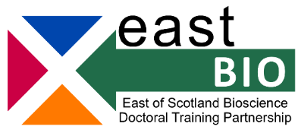
Foundation Masterclasses 2022/23
Introduction to Chemistry for Biologists
Optional for first- and second-year EASTBIO students
Workshop leaders: Dr Sergio Dall’Angelo and Dr Wael Houssen (Institute of Medical Sciences, University of Aberdeen)
Date: 10 March 2023, 11:00-16:00
Venue: Level 7 Conference Room, Institute of Medical Sciences Building (Foresterhill Campus, @11 on the linked map), Aberdeen
Workshop description / Learning outcomes:
This workshop will give the students an overview of:
1- Introduction to organic chemistry (types of chemical bonds, functional groups and their chemical transformation)
2- Chemistry of biomolecules (DNA, RNA, proteins and lipids)
3- Basic analytical techniques (NMR and UV spectroscopy, Mass spectrometry)
No previous knowledge on these topics is required.
Training Schedule:
11:00-11:15 | Welcome | SD, WH
11:15-12:00 | Introduction to Chemistry and Organic Chemistry | SD
12:00-13:00 | Proteins chemistry | WH
13:00-14:00 | Lunch break
14:00-14:30 | DNA & RNA chemistry | SD
14:30-15:00 | Lipids chemistry | SD
15:00-15:45 | Molecules characterisation techniques (NMR, UV, and MS) | WH, SD
15:45-16:00 | Final Q&A and closing remarks | WH, SD
Questions and discussion will be encouraged during each session
Participation requirements:
No prerequisite knowledge of organic chemistry is required.
Training webpage: http://www.eastscotbiodtp.ac.uk/foundation-masterclasses
For further info or any questions, please email enquiries@eastscotbiodtp.ac.uk

