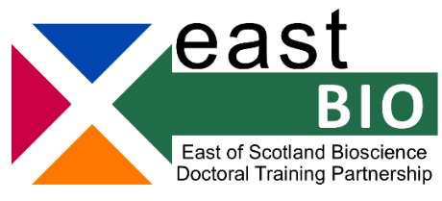
Foundation Masterclasses 2022-2023 – Set 2
Introduction to Biology for Chemists and Chemical Engineers
(optional for first- and second-year EASTBIO students)
Dr Ian Archer (Industrial Biotechnology Innovation Centre)
Online, 20 April 2023, 09:00-13:00
Workshop description
The chemical industry – in its broadest sense - is changing; companies want to sell products that have low carbon impact and crucially are derived from non-fossil resources. Interlinking chemistry, chemical engineering and biology is essential to deliver these ambitions.
The aim of this course is to enable chemists and chemical engineers to engage with biologists. It uses understanding of chemistry and engineering principles to explain what biologists mean when they use their own jargon. The course covers the basics of molecular biology, biochemistry and bioprocessing. We try to explain what is easy to do, what is (very) difficult to do, what is state of the art and what has been around for years. The course finishes with some commercial examples.
Schedule
The timings below are approximate and there will be short breaks in-between sessions.
9:00-9:45 | Introduction and some basic terminology
9:45-10:30 | Molecular biology basics, tools and ‘Omics
10:30-11:00 | Biochemistry basics
11:00-11:20 | Critical information seeking
11:20-11:50 | Bioprocessing
11:50-12:20 | Commercial examples
12:20-13:00 | Questions and close

This training can be recorded after concession is provided by training lead.
The Zoom link for this training will be shared directly with the registered students.
http://www.eastscotbiodtp.ac.uk/foundation-masterclasses
For any questions on this training, please email enquiries@eastscotbiodtp.ac.uk

