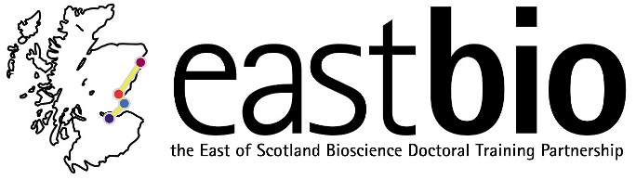

Thematic Research Training 2018-2019
Bioscience for Health (BfH) group
Second thematic meeting

Visual and Verbal Bend to Science Communications

University of Dundee, CTIR, 27 February 2019
9:30 – 16:30

Schedule

9:30 - 10:00 | Welcome Coffee – Outbreak area CTIR/WTB Mezz
10:00 - 11:00 | “My research without slides” student presentations (5-7 minutes). – Hands off the computer – use lay terms to explain your research
11:00 – 12:00 | Dr Suzanne Duce & Dr Jim Proctor: “Jalview – Dundee born and bred software to interactively and visually analyse and present your multiple sequence alignments”
12:00 – 12:30 | Dr Jim Proctor: “Data vis – Visualise your biological data – Essential tips, tricks and links”
12:30 – 13:30 | Lunch – Outbreak area CTIR/WTB Mezz
13:30 – 14:30 | Erin Hardee “Communicate your science effectively - Hands off the jargon – Ways to improve your presentation slang and style”
14:30 – 16:30 | Dr Mhairi Towler (Vivomotion): “Poster and Figure Presentations “

