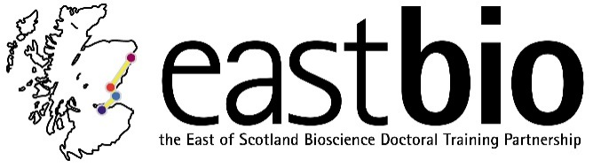
Thematic Research Training 2018-2019
Bioscience for Health (BfH) group
Chair: Dr Edgar Huitema (University of Dundee)

Session 1: “Fundamental <-> translational research” | Session 2: “A visual bend to science communication” | Session 3: “Healthy aging” | Session 4: “Sex matters”
Session leaders (local organisers)  Host supervisor:  Dr James Ainge  Student organiser:  Veronika Ambrozova  va26@st-andrews.ac.uk | Session leaders (local organisers)  Host supervisor:  Dr Helge Dorfmueller  Student organiser:  Kieron Lucas  k.y.lucas@dundee.ac.uk | Session leaders (local organisers)  Host supervisor:  Dr Sari Pennings  Student organiser:  Grace Bailey  G.Bailey@sms.ed.ac.uk; s1798029@ed.ac.uk | Session leaders (local organisers)  Host supervisor:  Dr Fiona Murray  fmurray@abdn.ac.uk  Student organiser:  Malcolm, Cameron c.malcolm.18@abdn.ac.uk
Programme available.  Date: 5 December 2018  Location: St Andrews, Bute Building | Programme available.  Date: 27 February 2019  Location: Dundee | Programme available.  Date: 4 April 2019  Location: Edinburgh, The Outreach Centre | Programme TBC.  Date: 28 June 2019  Location: Aberdeen

