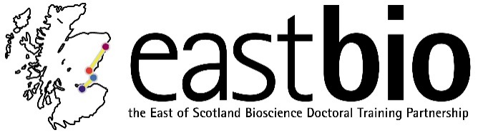
Thematic Research Training 2018-2019
Bioscience for Health (BfH) group
Chair: Dr Edgar Huitema (University of Dundee)

Session 1: “Fundamental <-> translational research” | Session 2: “A visual bend to science communication” | Session 3: “Healthy aging” | Session 4: “Sex matters”
Session leaders (local organisers)  Host supervisor:  James Ainge  jaa7@st-andrews.ac.uk  Sstudent organiser:  Veronika Ambrozova  va26@st-andrews.ac.uk | Session leaders (local organisers)  Host supervisor:  Dr Helge Dorfmueller  hczdorfmueller@dundee.ac.uk  Student organiser:  Kieron Lucas  k.y.lucas@dundee.ac.uk | Session leaders (local organisers)  Supervisor(s) name:  Supervisor(s) email:  Host student:  Grace Bailey  G.Bailey@sms.ed.ac.uk | Session leaders (local organisers)  Supervisor(s) name:  Supervisor(s) email:  Student(s) name:  Student(s) email:
Programme available.  Date: 5 December 2018  Location: St Andrews, Bute Building (room C28) | Programme available.  Date: 27 February 2019, 10:00-16:30  Location: Dundee | Programme TBC.  Date: April 2019  Location: Edinburgh | Programme TBC.  Date: June 2019  Location: Aberdeen

