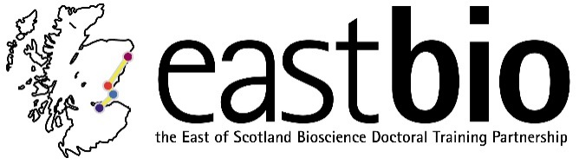
EASTBIO Research Skills Training (2017-2018)
Bioscience for Health (BfH) group

Session 1: “Introduction: Project from start to finish” | Session 2: “Maths, models, measurements” | Session 3: “Translation and impact of research”  Jointly with the WCUB group | Session 4: “TBC”  Jointly with the WCUB group
Session leaders:  Tracy Palmer  Ros Langston  r.f.langston@dundee.ac.uk  Student organisers:  Sian Jones &  Fiona Ramage | Session leaders:  Andrew Rambaut  Dr Danielle Gunn-Moore  Dr Emma Wood  Dr Paula Brunton  Dr Tom Burdon  Student organisers:  Verity Hill  Jordan Mitchell  Daniela Schnitzler  Tom Watson | Session leader:  Heather M Wilson  h.m.wilson@abdn.ac.uk  Arash Sahraie  a.sahraie@abdn.ac.uk  Paul Fowler  p.a.fowler@abdn.ac.uk  Hesse Constanze  c.hesse@abdn.ac.uk  Student organisers:  Bethany Allen  r03ba17@abdn.ac.uk  Matilda Cederblad  m.cederblad@abdn.ac.uk  Kathy Zafeiri  r01az17@abdn.ac.uk  Karina Kangur  r02kk17@abdn.ac.uk | Session leaders:  Gerben van Ooijen  Gerben.vanOoijen@ed.ac.uk  & Robin Allshire  robin.allshire@ed.ac.uk  Student organisers:  Helen Feord  helen.feord@ed.ac.uk  &  Tadhg Devlin  Tadhg.Devlin@ed.ac.uk
Programme available.  Date: 24 November 2017, 9:30 [10:00 start] – 16:00  Location: Dundee | Programme available.  Date: 6 April 2018, 10:30-16:00  Location: Edinburgh | Programme available.  Date: 20 April 2018, 10:30-16:00  Location: Aberdeen | Programme TBC.  Date: 13 June 2018  Location: Edinburgh

