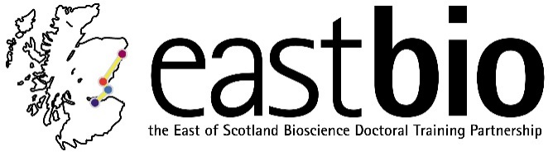
EASTBIO Research Skills Training (2017-2018)
Bioscience for Health (BfH) group

Session 1: “Introduction: Project from start to finish” | Session 2: “Maths, models, measurements” | Session 3: “Data interpretation - data visualisation” | Session 4: “Research dissemination: Steps for publication; publication models”
Session leaders:  Tracy Palmer  t.palmer@dundee.ac.uk  Ros Langston  r.f.langston@dundee.ac.uk  Student organisers:  Sian Jones  s.z.jones@dundee.ac.uk  Fiona Ramage  F.j.ramage@dundee.ac.uk | Session leaders:  Andrew Rambaut  a.rambaut@ed.ac.uk  Dr Danielle Gunn-Moore  danielle.gunn-moore@ed.ac.uk  Dr Emma Wood  Emma.Wood@ed.ac.uk  Dr Paula Brunton  p.j.brunton@ed.ac.uk  Dr Tom Burdon  tom.burdon@roslin.ed.ac.uk  Student organisers:  Verity Hill  s1732989@sms.ed.ac.uk  Jordan Mitchell  s0906993@sms.ed.ac.uk  Joseph Moore  s1411881@sms.ed.ac.uk  Daniela Schnitzler  s1137768@sms.ed.ac.uk  Tom Watson  s1322789@ed.ac.uk | Session leader:  Heather M Wilson  h.m.wilson@abdn.ac.uk  Arash Sahraie  a.sahraie@abdn.ac.uk  Paul Fowler  p.a.fowler@abdn.ac.uk  Student organisers:  Bethany Allen  r03ba17@abdn.ac.uk  Matilda Cederblad  m.cederblad@abdn.ac.uk  Aikaterini Zafeiri  r01az17@abdn.ac.uk | Session leader:  Student organisers:
Programme available.  Date: 24 November 2017, 9:30 [10:00 start] – 16:00  Location: Dundee | Programme TBC.  Date: February 2018  Location: Edinburgh | Programme TBC.  Date: April 2018  Location: Aberdeen | Programme TBC.  Date: June 2018  Location: TBA

